The Work of
Byron Katie

“There is no situation we can’t make peace with.” Byron Katie
“Life is simple. Everything happens for you, not to you. Everything happens at exactly the right moment, neither too soon not too late. You don’t have to like it… it’s just easier if you do.” Byron Katie
Trainer: Tammy Reid
Code: WORK201

CONTENTS

Online Classroom Contents Page 3 Who Is it That You Sit With 4
Three Kinds of Business 5
Proof of Truth Underlying Beliefs 6
The Turnarounds 7-8
Turnaround Exercise 9-10
The Work with a Partner 11-12
An Honest ‘No’ 13
Deepening Inquiry – When you think it is true 14
Asking For What I Want 15
Stressful Events 16
Seeking love, approval and Appreciation 17
Accepting the Gift of Criticism 18
Emotions List: How do you react? 19
Emotions List: Who would you be? 20
Judge Your Neighbour Worksheet 21
Facilitation Guide 22
Instructions for Doing The Work 23
One Belief at a Time Worksheet 24-25
Judge Your Body Worksheet 26

ONLINE CLASSROOM CONTENTS
Lesson 1
1.1 The Work With A Partner - Conflict Resolution
1.1.1 Introduction
1.1.2 Step 1 - Fill Out A Worksheet
1.1.3 Step 2 - Take Turns Reading The Worksheets
1.1.4 Step 3 - Facilitate Inquiry
1.1.5 Step 4 - Discussion
1.1.6 Conclusion
1.2 An Honest 'NO'
1.2.1 Part A
1.2.2 Part B
1.3 Deepening Inquiry - When You Think It Is True.
1.4 Asking For What I Want
1.5 Stressful Events
1.6 Seeking Love, Approval & Appreciation? Hopeless!
1.7 Accepting The Gift Of Criticism
1.8 The Work of Byron Katie for Therapists
1.9 Downloadable Worksheets
1.10 The Work of Byron Katie Resources

RECOMMENDED READING

Coumar, Anil, (2024), ‘Inquiry-Based Psychotherapy: Applying The Work of Byron Katie in Clinical Settings’, Swayam Prabha Psychological Services

WHO IS IT YOU SIT WITH?
“Do you recognize that the one in front of you is a reflection of your thinking only? They ‘are’ the story of who you think they are and what you think they do and don’t do.
Beyond you story of what they do or who ‘they’ are. Beyond all appearances and the story inside of you, what remains is the essence of? Know that your story is all that exists of us or ever has existed of us, or you.
The person before you is the opportunity to know and understand your thinking. What you think is all there is of you. As you experience the person you ‘think; you sit with, entertain the thought: “Are all situations here for me to learn about who and what I am?” Contemplate this.
Before you facilitate The Work today take a moment to silently remind yourself that the one sitting in front of you is here for you to understand and to learn about who you are, always.
“The Work is not about shame and blame. It is not about proving that you are the one in the wrong or they are the one in the right. The power of the turnaround lies in the discovery that everything you think you see on the outside is really a projection of your own mind. Everything is a mirror image of your own thinking. In discovering the innocence of the person you judged you eventually come to recognize your own innocence.” P.78 “Loving What Is” by Byron Katie. Source: Byron Katie ©BKI 2010
LITERAL LISTENING
- Practice listening to your client in the most literal sense.
- Notice falling into your own interpretations.
- Hear them out.
- Catch yourself when you want to finish a sentence for them or interrupt.
Consider these questions:
- Can I simply listen without thinking ‘I know what they are going to say’?
- Can I listen without thinking that I may, even remotely, have a better way?
- Is there some great piece of information that I have that they need to hear?
- Am I manipulating them to think of me in a certain way?
- Who would I be if heard them literally, and no longer engaged in trying to fix, impress or up stage them?
Exercise: Literal Listening: Manipulate the Coach
- Find a partner, One tells the story about anything they feel charged or opinionated about
- The other stays silent no matter what. The “Storyteller” tries to provoke the other to talk by attempting to engage them in their story.
- Use your most painful or frightening story and add a lot of drama to it.
- After (15) minutes, stop. Storyteller fills out the client follow up form, while the facilitator fills out the facilitator/listener form.
- Switch roles and repeat.

2. THREE KINDS OF BUSINESS
There are only three kinds of business in the universe: mine, yours, and God’s. “Reality is God, I noticed, but only because it rules.” Reality is always grace, benevolent. The unquestioned stories we superimpose on reality, in truth, are never as kind as reality.
Whose business is it if I’m feeling sad that there is suffering in the world? MY BUSINESS.
Whose business is it if you have a problem with my feeling sad? YOUR BUSINESS
Whose business is it if there is suffering in the world? GOD’S BUSINESS.
If I think that I know what you are thinking or what is best for you, then I am mentally living in your business. The effect of this is separation and loneliness. If you are over there living your life, and I am also over there living your life (mentally), then you are over there with you, I am over there with you and there is no one here for me. Of course I feel lonely and separated! I lonely me. No one else causes my loneliness. I do that.
Notice when you feel loneliness or separation. Are you mentally out of your business? If you are not sure, stop and ask yourself, “Mentally, whose business am I in?” Notice when you give uninvited advice either out loud or silently. Whose business are you in when you are giving unsolicited advice?
EXERCISE:
Whose business is it? Check off your personal responses below.
 | MY BUSINESS | THEIR BUSINESS | GOD’S BUSINESS
My height | T | T | T
Attending a concert | T | T | T
Rush hour traffic | T | T | T
My mother’s depression | T | T | T
The weather | T | T | T
War in the world | T | T | T
My brother’s vegetarianism | T | T | T
What I had for dinner | T | T | T
My boss’s anger | T | T | T
My body | T | T | T
When you understand the three kinds of business enough to stay in your own business, it frees you to see your own path with much more clarity. Eventually you may come to realize that you don’t have any business either. You may begin to give yourself the same courtesy that you give us.

© Byron Katie, 2017 Institute for The Work www.thework.com

PROOF OF TRUTH AND UNDERLYING BELIEFS

1. What is the best advice you could give someone you live with or work with or is close to you in some way? Take time to consider and write.

Example -Michael should watch his diet.

_____________________________________________________________________________________________________________________________________________________________________________________________________________________________________________________________________________________________

2. Write your proof of why each statement is valid advice.
-Michael is gaining weight
-Too much weight is not good for his health
-He is sluggish and tired
______________________________________________________________________________________________________________________________________________________________________________________________________________________________________________________________________________________________________________________________________________________

3. Find the underlying beliefs in the ‘proof’ statements.
-People should not get fat
-He should have energy.
- People should live active fulfilling lives
-People should be healthy
_____________________________________________________________________________________________________________________________________________________________________________________________________________________________________________________________________________________________

4. Break into pairs and investigate your list of underlying beliefs. If you are having difficulty naming underlying beliefs utilize your partner and explore possible beliefs held in your proofs. Make further notes of any underlying beliefs that may arise through inquiry. 30- 40 minutes each.

Adapted from ‘Loving What Is’ by Byron Katie
©2017 Byron Katie Inc., www.thework.com

THE TURNAROUNDS

Next turn your statement around. The turnarounds are an opportunity to consider the opposite of what you believe to be true. You may find several turnarounds.
For example: “Paul should understand me” turns around to:

- Paul does understand me” (Isn’t that reality sometimes)
- I should understand me (It’s my job, not his)
- I should understand Paul (Can I understand that he doesn’t understand me?)

Le yourself fully experience the turnarounds. For each one ask yourself, “Is it true or truer?” This is not about blaming yourself or feeling guilty. It’s about discovering alternatives that can bring you peace.

The Turnaround for # 6
The turnaround for statement 6 is a little different.:
“I don’t ever want to experience an argument with Paul again” turns around to:
- “I am willing to experience an argument with Paul again”
- “I look forward to experiencing an argument with Paul again.”

Number 6 is about welcoming all your thoughts and experiences with open arms. If you feel any resistance to a thought, your Work is not done. When you can honestly look forward to experience that have been uncomfortable there is no longer anything to fear in your life – you see everything as a gift that can bring you self-realization.

After you've investigated your statement with the four questions, you're ready to turn it around. Turnarounds are opportunities to experience the opposite of your original statement and see what you and the one you judge have in common.

For example:
"I'm angry at Paul because he doesn't understand me" turned around to "I don't understand me."

Is that as true or truer? Could it be that I don't understand myself—perhaps the way I repeatedly get so angry at Paul? If I don't understand myself, can I see how Paul wouldn't either? Another turnaround could be: "I don't understand Paul." Can you find that?

Be creative with the turnarounds. They are revelations, showing you the unseen pieces of yourself reflected back through others. Go inside after each turnaround. Let yourself feel it. Ask yourself if any of your turned-around versions seem as true as or truer than your original thought, and if they do, find three genuine ways in which each of them is true.

As I began living the turnarounds, I noticed that I was everything I called you. You were merely my projection. Now, instead of trying to change the world around me (this didn't work, but only for 43 years), I can put the thoughts on paper, investigate them, turn them around, and find that I am the very thing I thought you were. In the moment I see you as selfish, I am selfish (deciding how you should be). In the moment I see you as unkind, I am unkind. If I believe you should stop waging war, am I waging war on you in my mind? If so, I am teaching war.

The turnarounds are your prescription for happiness. Live the medicine you have been prescribing for others. The world is waiting for just one person to live it. You are the one.
Statements can be turned around:
- To yourself, to the other, (You give what you want to yourself)
- To the opposite, (You give what you want to the other)
- To "my thinking," wherever it applies. (Where is the story happening really?)
- To the opposite of the original statement (e.g.: If he should, then he shouldn’t – it’s what is,
sometimes)
Try and find a minimum of three genuine examples in your life where each turnaround is as true as or truer than your original statement.
The turnarounds are an opportunity to consider the opposite of what you believe to be true. You may find several turnarounds.
More examples of turnarounds:
"He should understand me" turns around to:
- He does understand me. (Isn’t this reality sometimes?)
- I should understand him. (Can I understand that he doesn’t understand me? And notice that sometimes I don’t understand him either)
- I should understand myself. (It’s my job not his and do I?)

"I need him to be kind to me." turns around to:
- He is kind to me.
- I need me to be kind to him. (Can I live it?)
- I need me to be kind to myself.

"He is unloving to me." turns around to:
- He is loving to me. (To the best of his ability)
- I am unloving to him. (Can I find it?)
- I am unloving to me (When I don't inquire.)

"Paul shouldn't shout at me." turns around to:
- Paul should shout at me.(Obviously in reality, he does sometimes. Am I listening?)
- I shouldn't shout at Paul.
- I shouldn't shout at me. (In my head, am I playing over and over again Paul's shouting? Who’s more merciful, Paul who shouted once, or me who replayed it out a 100 times?)

EXAMPLES OF FURTHER TURNAROUNDS:
I am never good enough for my family  I am always enough for my family  My family is never good enough for me  My thoughts about my family are never good enough for me  I never have enough money  I always have enough money  My money is never enough for me  My thinking about my money is never enough  I am not worthy  I am worthy  My thinking about myself is not worthy of me | Sam does not support me when I need her to  I do not support myself when I need me to  I do not support Sam when she needs me to  Sam does support me when I need her to  My daughter’s drug addiction is running my life  My addiction to my thinking is running my life  My addiction to my daughter is running her life  My daughter’s addiction does not run my life    My addiction is running my life

Excerpt from www.thework.com By Byron Katie ©2017 Byron Katie Inc., www.thework.com
TURNAROUND EXERCISE

Turn the following thoughts around.

Tom does not respect me.
To myself: ____________________________________________________

To the other: __________________________________________________

To the opposite: _______________________________________________

Martha lies to me.
To myself: ____________________________________________________

To the other: __________________________________________________

To the opposite: _______________________________________________

I’m too fat.
To the opposite: _______________________________________________

To my thinking or my thoughts: ___________________________________

Pete should understand me.
To myself: ____________________________________________________

To the other: __________________________________________________

To the opposite: _______________________________________________

Joan should be more considerate.
To myself: ____________________________________________________

To the other: __________________________________________________

To the opposite: _______________________________________________

Louis smokes too much.
To the opposite: _______________________________________________

To the other: __________________________________________________

To myself: ____________________________________________________

Dan doesn’t appreciate my work.
To the opposite: _______________________________________________

To myself: ____________________________________________________

To the other: __________________________________________________

I need Sally to be healthy.
To the opposite: _______________________________________________

To myself: ____________________________________________________

To my thinking: ________________________________________________

I want my son to be happy.
To the opposite: _______________________________________________

To myself: ____________________________________________________

To the other: __________________________________________________

Greg is mean to me.
To the opposite: _______________________________________________

To myself: ____________________________________________________

To the other: __________________________________________________

People shouldn’t abuse animals.
To the opposite: _______________________________________________

To myself: ____________________________________________________

To the other: __________________________________________________

Copyright © 2017 Byron Katie Inc. www.thework.com
THE WORK WITH A PARTNER
(CONFLICT RESOLUTION)
Introduction

The following is a powerful exercise that can be done by two (or more) people who seek resolution and the end of conflict. The key when working with another person is to be clear that The Work is for you, not for the other, and to end the conflict within yourself. Both people are there to go inside and discover their own freedom. After all, it is the truth that sets us free.

You may be tempted to use this exercise as a forum to get your partner to change. Having such a motive is manipulative, leading to frustration and further misunderstanding. The Work is not for people who want to be right. It’s for people who want to be free. We have been other-realized forever. The Work is about self-realization.

Step 1 – Fill out a Worksheet

Each person involved in the conflict fills out a Judge-Your-Neighbor Worksheet (available from Katie’s book, Loving What Is, or from www.thework.org) with their honest, direct, and petty judgments of the other.

Step 2 – Take turns reading the Worksheets

Decide who will be Partner A and who will be Partner B. Partner A shares his or her Worksheet aloud, statement by statement, without crosstalk, speaking directly to Partner B in the second person. For example, “I’m angry at Paul because he doesn’t love me” becomes “Paul, I’m angry at you because you don’t love me.” After each statement, Partner A pauses and makes eye contact with Partner B.

Partner B’s job is to meditate on each statement, one by one, and see where Partner A is right. Whether Partner B finds it or not, he or she replies only with “Thank you.” Only that—no more and no less. Partner A has just shared the gift of his or her painful thoughts. Partner B, notice any desire you have to justify or defend. Stop, listen, and feel, and respond only with “Thank you.”

When Partner A has finished reading all the statements from the Worksheet, switch positions so that Partner B now reads his or her Worksheet aloud, and Partner A listens, following the same procedure outlined above.

Step 3 – Facilitate inquiry

If a third party is present to facilitate, this facilitator helps both partners to question their Worksheet statements in turn (after Partners A and B have completed reading their Worksheets to each other).

If there is no third party present, Partner A facilitates Partner B through the entire Worksheet, going through all four questions and the turnaround for each statement. At this point, Partner B reads the Worksheet as he or she wrote it, in the first person (“I’m angry at Paul because he doesn’t love me”).

When asking question number three, you may want to add these sub-questions:
- “How does it feel when you think that thought? Where do you feel that thought in your body? And notice in your life if this is when you go to the refrigerator, cigarette, shopping, alcohol, wanting a different partner.”
- “How do you treat Partner B when you think that thought?” Be specific. How do you treat yourself?”
- “How does it feel to treat Partner B that way?”
- “Does that thought bring stress or peace into your life?”

Partner A’s job is to listen only. Notice the temptation to add or subtract something. Stop. Go back to listening. This is an active role—remember that this inquiry is for you, not for the other.

When Partner B has finished questioning the Worksheet, the roles are reversed. Partner B facilitates Partner A.

Step 4 – Discussion

Now discuss what you realized about yourself, how you, not your partner, could live differently, and how those changes might contribute in a positive way to your own life as well as to the relationship. As you share—from the heart—your own possible changes, ask for your partner’s help in this process. Ask him or her to help as you make changes in your life by reminding you each time you slip back into your old patterns—but ask only if that is what you truly want. Make it a game to see if your partner can catch your slips before you catch them yourself. Discuss subtle signals to use in this process and kinder ways of communicating. Pointing out the other’s patterns without kindness may feel hurtful inside you. Also, the agreement can end at any time. Be gentle and respect when your partner is too fragile for reminders and does not want your feedback or help. Don’t try to do this exercise perfectly; have fun instead. Change doesn’t have to be a stressful experience.

When you notice that you step into your partner’s business without permission, stop and move back into your own again. Notice the stress that comes from being mentally out of your own business, the stress of trying to change another human being before he or she has sincerely asked for your assistance. This process is the beginning of the end of war with your partner.

Conclusion

Simply reading Worksheets to each other can seem uncaring if you are not deeply committed to questioning your statements through inquiry. This is an opportunity to use another person to get closer to the parts of yourself that you may not have seen clearly, and thus allows the possibility of more intimacy with yourself and the other person. By relating more deeply and honestly to ourselves, we find freedom and joy in relating to the world. Couples fight, separate, and divorce—this often seems to be the way of it. However, in these situations, there is no reason not to love and support in the deepest way the one you are with, the one you are leaving or the one who is leaving or has left you. Until there is nothing anyone can do to keep you from loving your partner, your work isn’t done. Your partner’s job is to test you each day just by living his or her life.

Have fun, and welcome to The Work.

From www.thework.com © 2017 Bryon Katie Inc

PART 2: AN HONEST ‘NO’

Honest communication begins with you communicating with yourself. It means responding with what is true for you, regardless of how someone may react to your answer. First you have to discover what is really true for you. A dishonest yes is a no to yourself.

Part A

- Think of a situation in your life where you have difficulty or cannot say your honest ‘no’. Imagine simply saying no when you feel torn by a request. Now, look at what you ‘think’ would happen if you said ‘no’. Write down the fearful thoughts that arise. Eg. “If I say no, he won’t love me” or “if I say no, she’ll think I don’t love her.” __________________________________________________________________________________________________________________________________________________________________________________________________________________________________________________________________________________________________________________________________________________________________________________________________________________________________________

- Find yourself a partner and pair up. Simply read your list of thoughts that keep you in fear and unable to respond with an honest no.

- After you have both read your lists, take turns doing the inquiry on the most stressful thoughts that you have written. Continue until time is called.

Part B

People ask for many things. Once you discover that your honest answer is no, communicating it is simple when you communicate your love at the same time. The no is one part of your answer, and the acknowledgement of your love is the other part. Here are some examples of how to express your honest no to these requests and still let people know that you hear them and respect that they’re asking for what they want.
Thank you for asking, and no.
I understand, and no.
You could be right, and no.
I can see that it works for you, and no.
I want to please you, and no.
I hear you. I care about you. And...
I understand. What do you suggest?
I can see that it works for you, and it's not my experience
I want to want to give you what you are asking for, and I'm not able to yet.
I don’t know yet. Please ask me later

- Find yourself another partner. Partner A explains the situation to other so that they can play the part of the person to whom you have difficulty saying ‘no’. Partner B asks partner A for what they want. Partner A practices saying no using examples above that seem most caring, natural and true for you.

- Change positions so that each partner has the opportunity to practice saying ‘no’.

Adapted from ‘I Need Your Love, Is it True” by Byron Katie
© 2017 Byron Katie Inc www.thework.com

DEEPENING INQUIRY – WHEN YOU THINK IT IS TRUE

Prompts to find underlying beliefs

From your worksheets, take two statements that you feel strongly are true and list them here. Allow yourself to stay in the story.
____________________________________________________________________________
____________________________________________________________________________
____________________________________________________________________________
____________________________________________________________________________

Now apply the following prompts to each statement listed above and make a list in your notebook. You may find each prompt does not apply to each statement. Make lists where the prompt does apply.

- Read your statement and add “ . . . and that means that _______.” (Example: Mary doesn’t listen to me and that means that when she’s not she thinks I am boring or that means she doesn’t like me, that means she doesn’t understand me. Or that means she’s rude, and uncaring.)
- ____________________________________________________________________________________________________________________________________________________________________________________________________________________________________________________________________________________________________________________________________________________________________________________________________________________________________

- Read your statement and ask yourself “What do you think you would have if reality was cooperating with you?” (Example: If Mary would listen to me I would feel heard, I would be happy, it would mean she loves me, she would give me what I want, etc.) ______________________________________________________________________________________________________________________________________________________________________________________________________________________________________________________________________________________________________________________________________________________________

- Read your statement and imagine your worst fears lived out. Take it to the limit. ( For example: if she doesn’t listen to me our relationship will fall apart, then I would be alone, no one else would want to be with me, And then, ______. And then, _______. Wait, sit with it and see what fears arise. Be specific to your life.) ________________________________________________________________________________________________________________________________________________________________________________________________________________________________________________________________________________________

- Pair up and choose three or more underlying beliefs from your lists and do the Inquiry on these statements. Be sure to do the turnarounds and when appropriate give examples. You’ll have approx. 30 – 45 minutes each to take your beliefs to inquiry.

Adapted from ‘Loving What Is” by Byron Katie
© 2017 Byron Katie Inc www.thework.com
ASKING FOR WHAT I WANT

- How many times do you not ask for what you want or need in a situation? How often do you abandon yourself in this way? What stops you from asking? What do you believe about the other or about yourself when this is happening?

Think of a time when you neglected to ask or inform the other of what you wanted or needed. Experience the fear, hesitation or anger that was present at this time. Write down the beliefs you held that kept you from taking the risk of asking. They could be thoughts about yourself or about the other. They could be thoughts about what others will think of you. Make your list here.
___________________________________________________________________________________________________________________________________________________________________________________________________________________________________________________________________________________________________________________________________________________________________________________________________________________________________________________________________________________________________________________________________________________________________________________________________________________________________________________________________________________________________________________________________________

- Find yourself a partner and pair up. Simply read your list of thoughts that keep you in fear and unable to give yourself the gift of asking.

- After you have both read your lists, take turns doing the inquiry on the most stressful thoughts that you have written. Continue until time is called.

Adapted from ‘Loving What Is” by Byron Katie
© 2017 Byron Katie Inc www.thework.com

STRESSFUL EVENTS

Make a written list of spontaneous events in your day or the last week that were stressful. Identify and list the beliefs that caused each effect.
We will break up into pairs and work your stressful beliefs.

Prompts:

I said ___________________________ because _____________________
_____________________________________________________________
Example: I said it didn’t matter because I didn’t want her to see how angry I was.
I said too much because I wanted to appear like I knew something.

I said ___________________________ because _____________________
_____________________________________________________________

I didn’t say ________________________ because ____________________
_____________________________________________________________

I didn’t say ________________________ because ____________________
_____________________________________________________________

I did _____________________________ because ____________________
_____________________________________________________________

I did _____________________________ because ____________________
_____________________________________________________________

I didn’t _________________________ because ______________________
_____________________________________________________________

I didn’t _________________________ because ______________________
_____________________________________________________________

I thought _________________________ because ____________________
____________________________________________________________

I _________________________ because __________________________
____________________________________________________________

Adapted from ‘Loving What Is” by Byron Katie
© 2017 Byron Katie Inc www.thework.com
SEEKING LOVE, APPROVAL AND APPRECIATION? HOPELESS!

- Make a written list of everything you did or didn’t do, said or didn’t say today or yesterday while walking, talking or eating etc. that was dishonest, manipulative, or was not genuine in some way and tell why you did it, what did you want?

I said
__________________________________________________________________________

__________________________________________________________________________

because I wanted ______________________________________________________

I said
__________________________________________________________________________

__________________________________________________________________________

because I wanted ______________________________________________________

I did
__________________________________________________________________________

__________________________________________________________________________

because I wanted ______________________________________________________

I didn’t
__________________________________________________________________________

__________________________________________________________________________

because I wanted ______________________________________________________

I didn’t say
__________________________________________________________________________

__________________________________________________________________________

because I wanted ______________________________________________________

Continue the list in your journal.

- Pair up. Participant “A” reads entire list. Participant “B” gives “A” the inquiry one by one to each statement. (Inquire of “I wanted …” , and then inquire of the underlying belief – “They should ….” ) e.g. “I want them to like me…” underlying belief.. ‘they should like me’.
30 minutes each. Then swap roles.

ACCEPTING THE GIFT OF CRITICISM

When we understand precisely what criticism is really about, we find that criticism it is one of most powerful tools for self-realization and growth – if you really want to know the truth.

Here are some steps on how to use and understand criticism for your highest benefit.

When someone says you are “wrong, unkind, unclear, lazy” etc feel it.
Settle into it before you strike out.
Ask yourself, “Is it true?”
“Could they be right?” Wait for the answer.

After the criticism ask yourself:

“Was that stressful or painful?”

If the answer is yes, then this is a sign that you believe that the criticism is true, and that you haven’t dealt with it or gone deeply enough yet. If you want to end the war in your own life and mind, you may decide to gently go deeper as your inquire and discover the truth of the criticism within yourself. This is where all war ends.

No matter what anyone says to, or about, you if you experience stress, then you are the one who is suffering from your hidden secret – the secret you hide even from yourself in the moment – and the mind will do its job at this point which is to attack. Your own mind’s attack is the cause of stress. Stress is the signal that it is time to ask yourself, time to inquire, an opportunity for you to know the truth. Stress is always an opportunity to experience forgiveness with the people you judge and those who judge you, and to end the stress within you. Forgiveness cannot be found anywhere else. Forgiveness is when you realise that what you think happened didn’t.

Being honest with yourself and being vulnerable can be the end of the illusion of being manipulated in any way. When you are genuinely humble, there is no place for criticism to stick. This is where clarity takes on life as effective, kind action.

Inquiry is a direct internal path to freedom from the lie and from deep secrets, and therefore, freedom from the fear of your lies being discovered.

© 2017 Bryon Katie Inc. All rights reserved
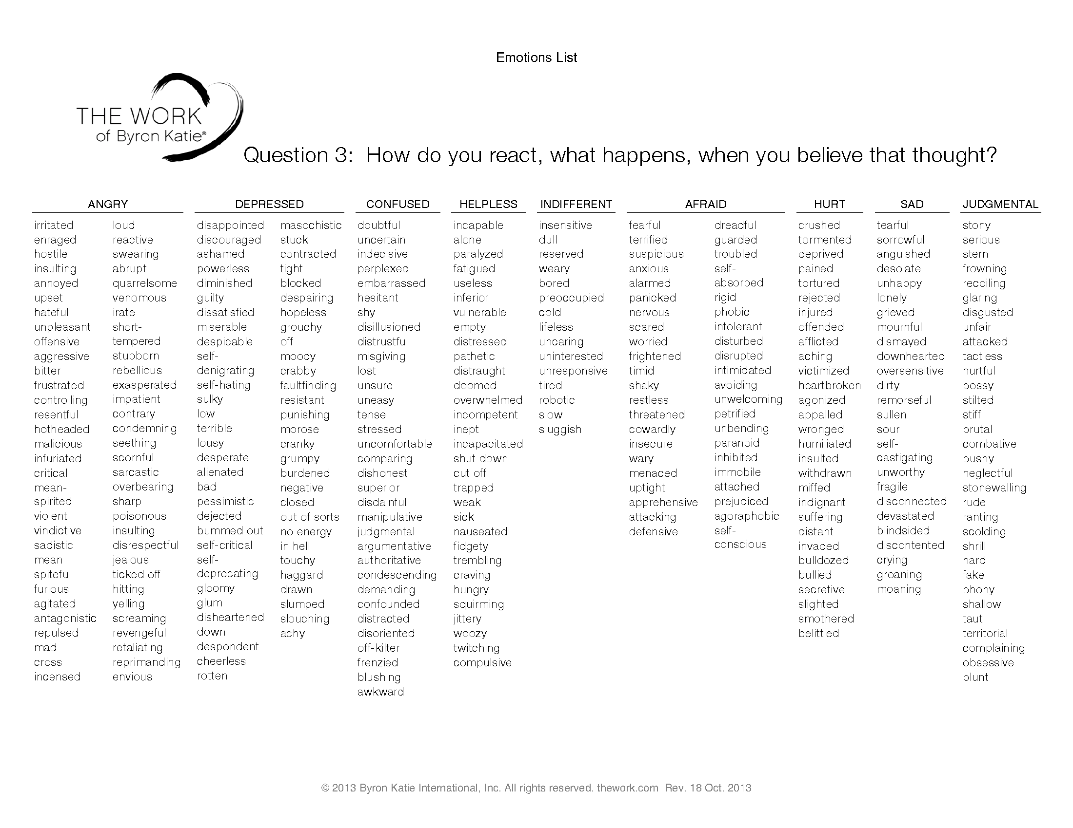
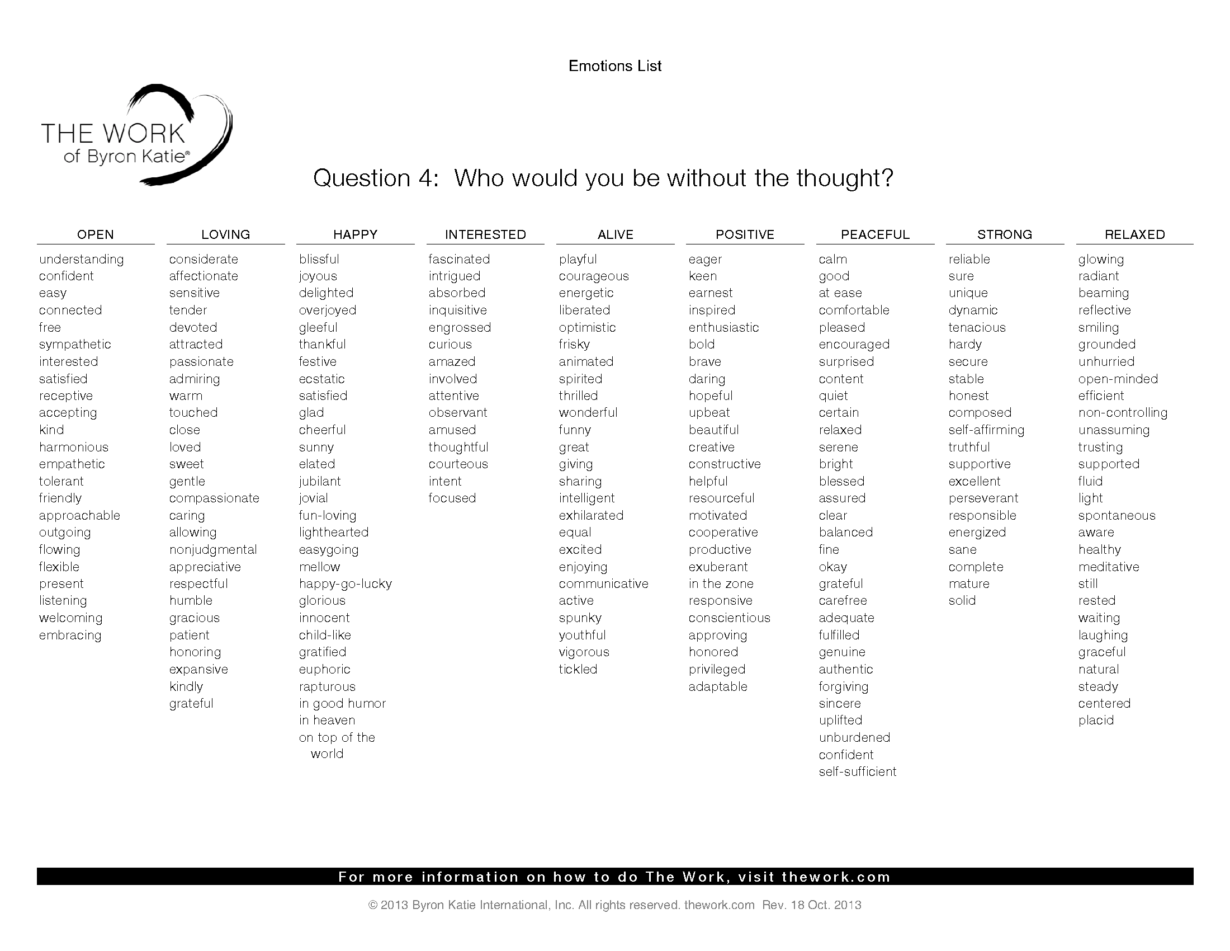
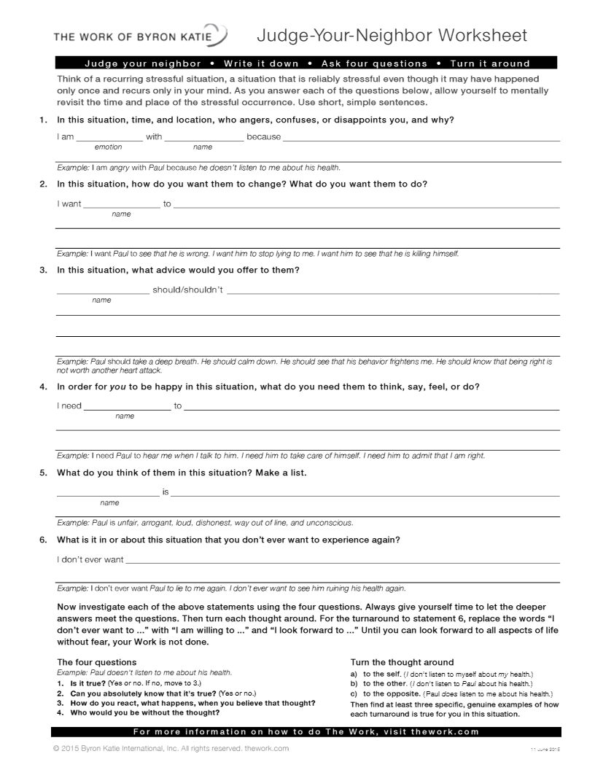

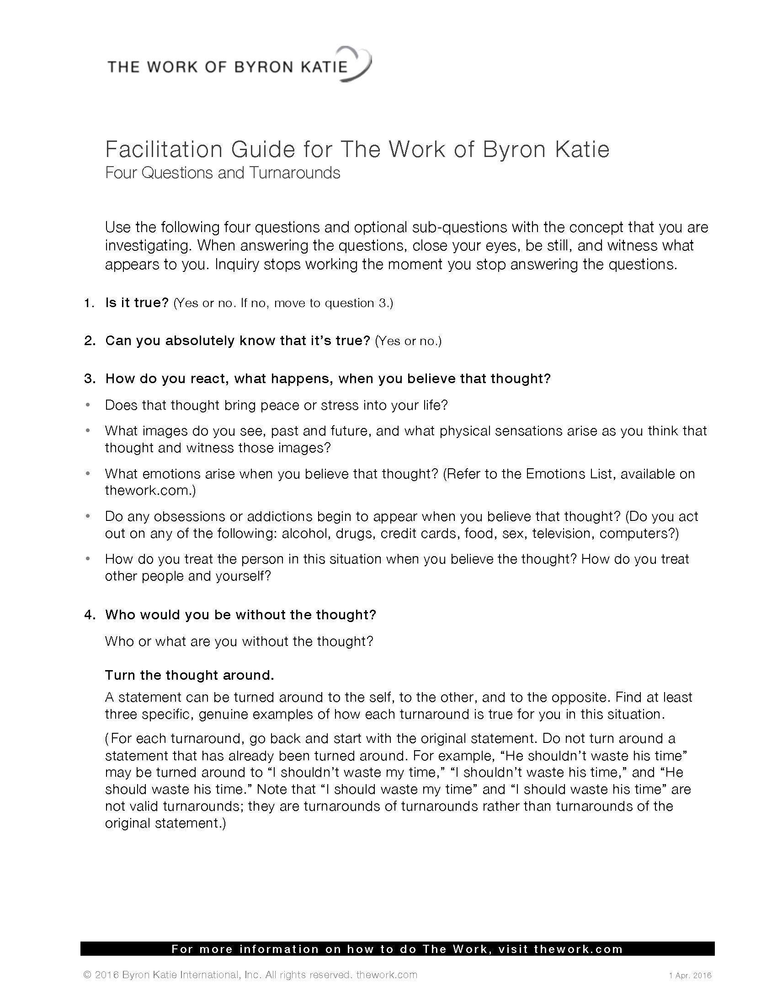

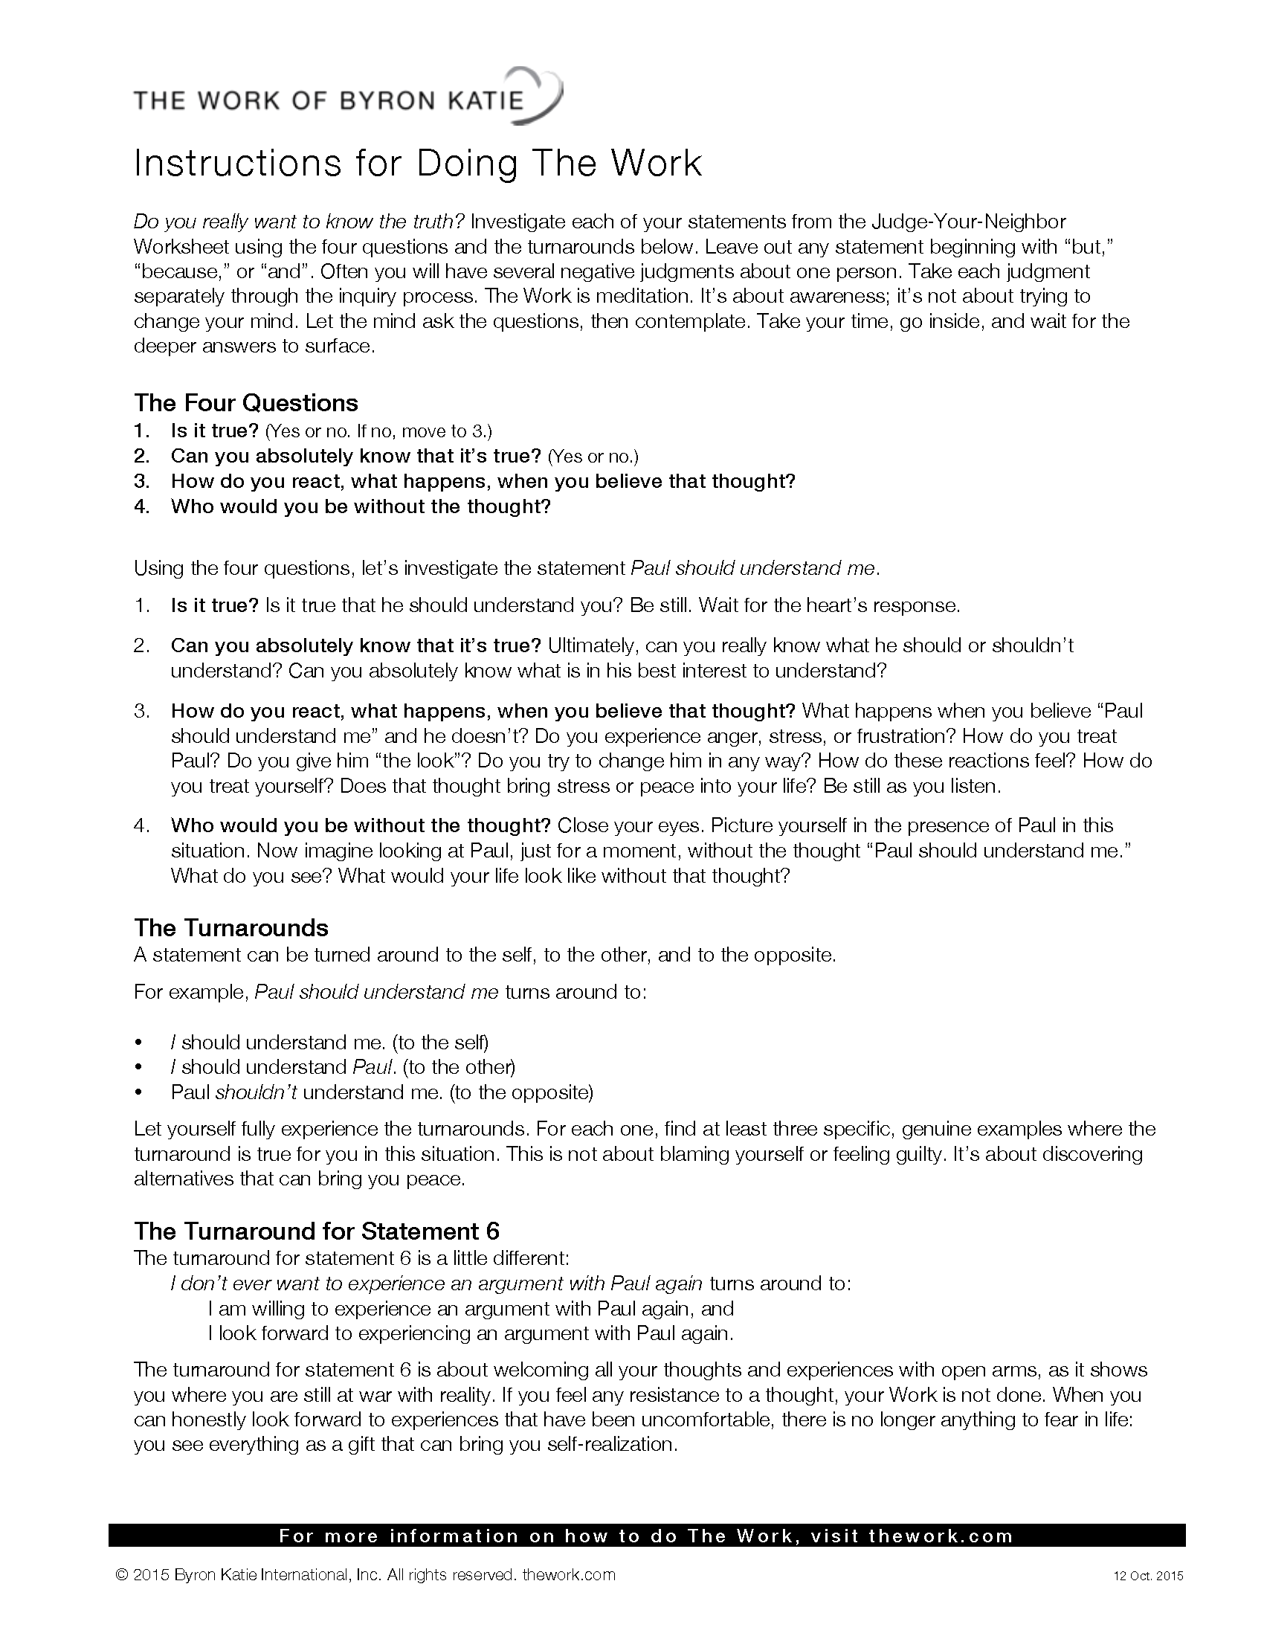
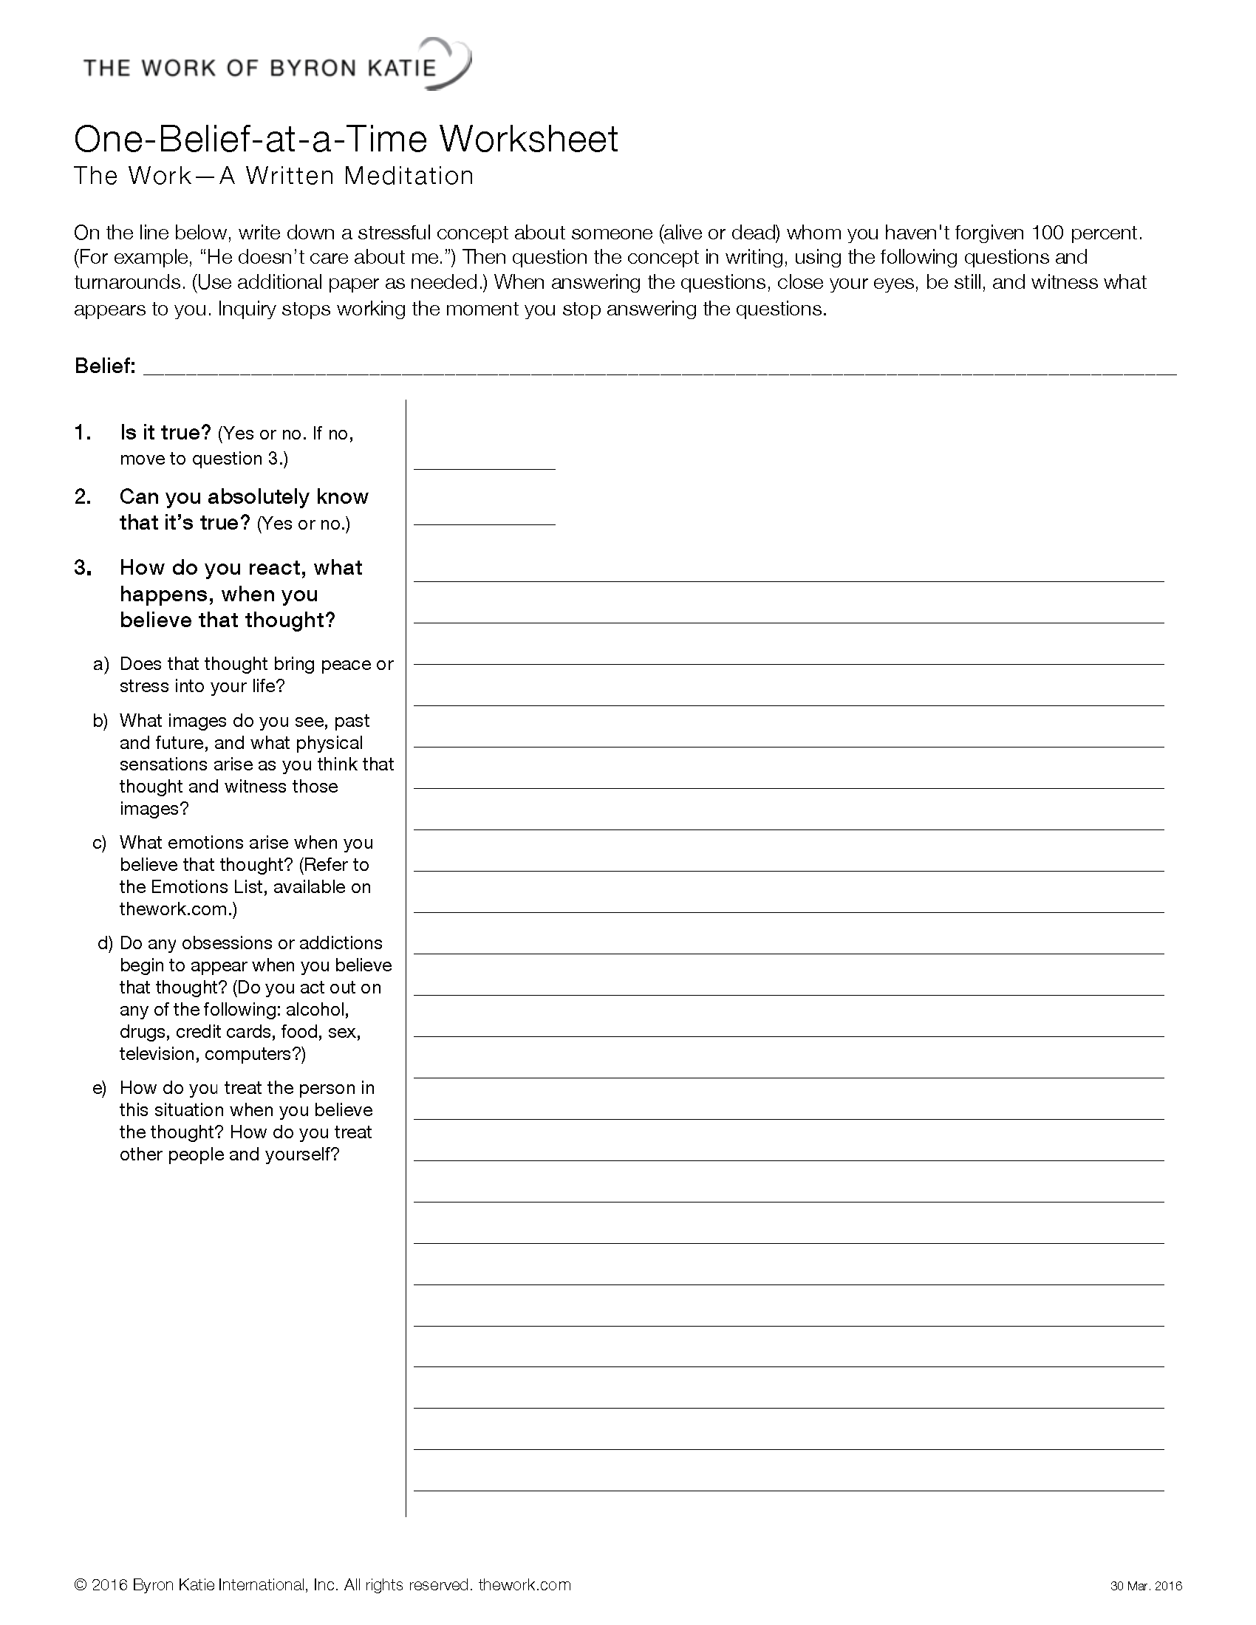
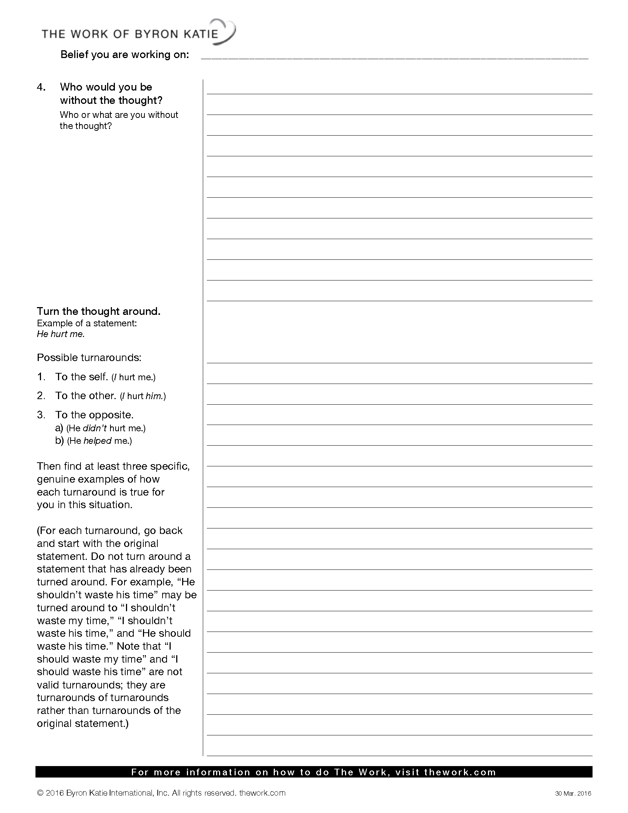
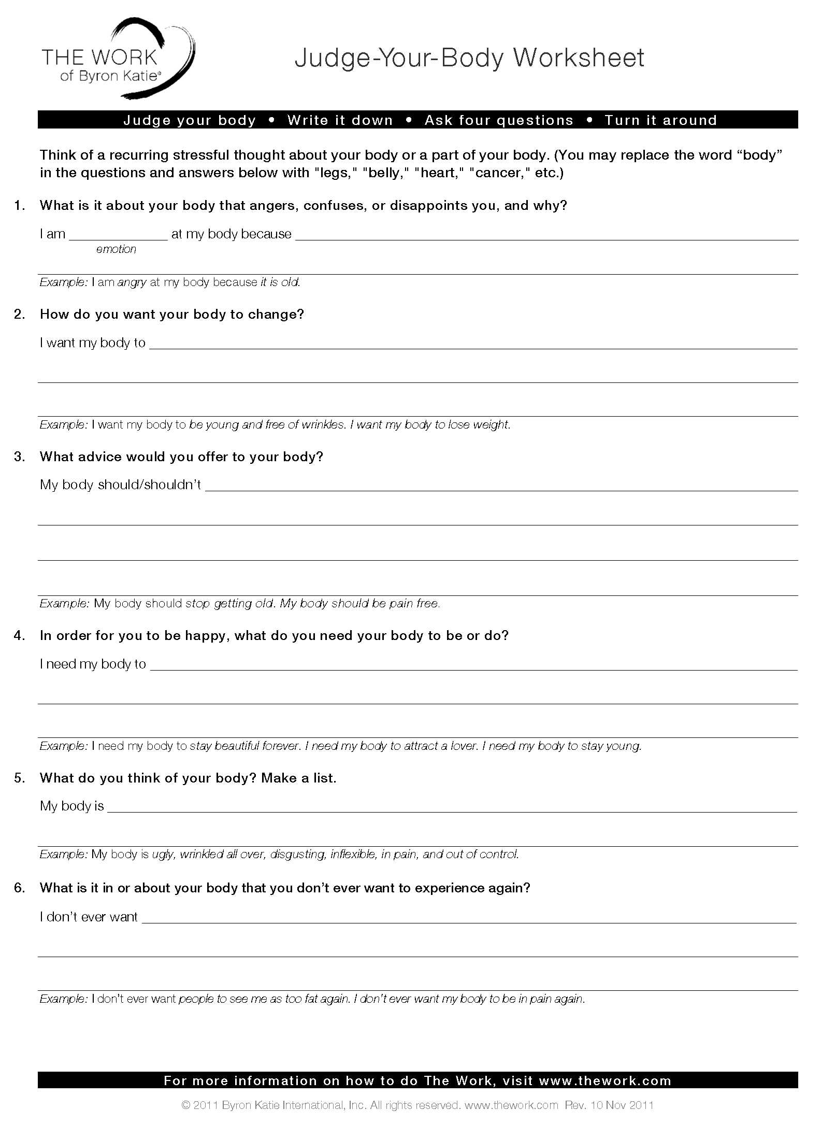



Want More?

Join Us for
The Certificate in The Work of Byron Katie
www.awakening.com.au/course/the-work-of-byron-katie/

Or explore our other courses:

- The Certificate in Holistic Counselling
- The Diploma in Holistic Counselling
- Family Constellations
- Authentic Communicator
- Weaving the New Dreaming with Aunty Jenny Thompson
- Embracing Diversity
- Crisis Counselling
- Navigating Grief and Loss
And much more
www.awakening.com.au

