

The Work of
Byron Katie

“The only way I will ever be great to myself is not what I do to my body, but what I do to my mind.” Ramtha
Trainer: Rosie Stave
Code: WORK201

CONTENTS

Online Classroom Contents Page 2 The Weekend 3
Literal Listening: Who Is it Your Sit With 4-5
Three Kinds of Business 6
What Would Make Me Happy 7
How Beliefs Work 8
Transparent Beliefs and Examples 9
Underlying Beliefs 10
Universal Beliefs 11
Judge Your Neighbour Worksheet 12
One Belief at a time Worksheet 13-14
Facilitation Guide 15
Instructions for Doing The Work 16
The Turnarounds 17-18
The Turnaround for Qu 6 and Qu 5 19-20
Turnaround Exercises 21-24
Accepting the Gift of Criticism 25
Proof of Truth & Underlying Beliefs 26
Emotions Lists 27-28
Using the Worksheets 29
Mini-Worksheets 30
SELF-PACED LEARNING 31-32

ONLINE CLASSROOM CONTENTS PART I

Lesson 1  - The Great Undoing By Byron Katie  1.1.1 A Few Basic Principles  1.2 Who Is It You Sit With?  1.3 Literal Listening  1.3.1 An Experiment In True Listening - Audio  1.3.2 Exercise: Literal Listening- Manipulate The Coach  1.3.3 Peer Assessment Literal Listening - Follow Up  1.4 Three Kinds Of Business  1.5 What Would Make Your Happy?  1.6 A Good Wife/Husband/Partner Should...  1.7 How Beliefs Work  1.7.1 The Mechanisms Of A Belief  1.7.1.1 How Do You Experience Life  1.7.1.2 Examples of Beliefs  1.7.2 Transparent Beliefs  1.7.3 Underlying Beliefs  1.7.4 Universal Beliefs | Lesson 2 Worksheets & Turnarounds  2.1 Worksheets  2.1.1 Instructions For The Work Of Byron Katie  2.1.2 Judge Your Neighbour Worksheet  2.1.3 One Belief At A Time Worksheet  2.1.4 Facilitation Guide  2.1.5 Yellow Cards & Mini Worksheet Yellow Cards  2.1.6 Emotions List For Question 3  2.1.7 Emotions List For Question 4  2.2 Filling Out A Worksheet  2.2.1 When Would You Use A Worksheet?  2.3 The Turnarounds  2.2.1 Example #1  2.2.2 Example #2  2.2.3 Be Creative With Turnarounds  2.2.4 More Examples Of Turnarounds  2.4 Turnaround Exercises  2.4.1 Further Turnaround Exercises  2.5 The Turnaround For Question #5  2.6 Loving What Is: Meeting Reality  2.7 The Work of Byron Katie: A New Psychotherapy
Lesson 3 The Gift of Criticism, Proof Of Truth & Resources  3.1 Accepting The Gift Of Criticism  3.2 Proof of Truth And Underlying Beliefs  3.3 Resources  3.3.1 Text Book  3.3.2 Books  3.3.3 Internet, Websites & Youtube Videos  3.3.4 Helpline  3.3.5 Inquiry Circles  3.3.6 Yellow Card Templates  3.3.7 Apps - Phone & ipad | The Work of Byron Katie Learning Activities  Module 3: The Work of Byron Katie Learning Activities Part B Self Awareness & Practical

THE WEEKEND
- LITERAL LISTENING
Literal Listening Exercise regarding Listening FOR the Client
Being able to really listen and hear the other person, free of any internal dialogue of ones’ own, frees the practitioner to be available for the client. This also gives the practitioner greater access to their own sensory acuity regarding the clients’ core beliefs/lynch pins/identities.
- THE WORK: THE GREAT UNDOING by Bryon Katie
- An enquiry into the Truth of beliefs that have been held as a given premise and that have never been questioned.
- Three Types of Business
- Uncovering and specifically identifying the personal Core Beliefs and Identities that are causing Suffering.
- Discovering and undoing the story/thoughts/reactions/attitudes we have surrounding parents, life, relationships, money, sex and more, reveals our inherent nature: a deep experience of Beingness, peace and the natural flow of love.
- Use of “The Work” in freeing the client and practitioner from fixed attention on issues, behaviour, fears, feelings of inadequacy. Liberating the practitioner from any desire to "fix" them or "figure it out for them" at a much deeper level.
- THE GIFT OF CRITICISM

Criticism is one of the things we defend against, most. Being able to remain in my own integrity, and receive criticism, feel it, and check within allows the opportunity to:
- reveal if there is a hidden belief yet to be embraced within oneself and/or
- it is simply the other person’s projection.
Teaching Methods used: Individual, pair and group exercises, group discussion including scenarios relevant to participants understanding, specially designed written exercises and role-play. Instructor role-play skills, coaching, handouts, manual and recommended texts.
MODULE OUTCOMES
- Identify how the mind works and how it keeps existing beliefs and stories alive
- Gain skills in meeting reality and experience the essential nature of beingness.
- Learn the types of business and the effect of being in each
- Gain skills and experience in effective techniques to uncover beliefs and inquire into
- Alleviate the pressure practitioners have about taking on personal responsibility for clients issues
- Skills in how to move beyond outdated beliefs and unproductive identities.
PART II
See website www.awakening.com.au/courses for details.
1. WHO IS IT YOU SIT WITH?
“Do you recognize that the one in front of you is a reflection of your thinking only? They ‘are’ the story of who you think they are and what you think they do and don’t do.
Beyond you story of what they do or who ‘they’ are. Beyond all appearances and the story inside of you, what remains is the essence of? Know that your story is all that exists of us or ever has existed of us, or you.
The person before you is the opportunity to know and understand your thinking. What you think is all there is of you. As you experience the person you ‘think; you sit with, entertain the thought: “Are all situations here for me to learn about who and what I am?” Contemplate this.
Before you facilitate The Work today take a moment to silently remind yourself that the one sitting in front of you is here for you to understand and to learn about who you are, always.
“The Work is not about shame and blame. It is not about proving that you are the one in the wrong or they are the one in the right. The power of the turnaround lies in the discovery that everything you think you see on the outside is really a projection of your own mind. Everything is a mirror image of your own thinking. In discovering the innocence of the person you judged you eventually come to recognize your own innocence.” P.78 “Loving What Is” by Byron Katie. Source: Byron Katie ©BKI 2010
LITERAL LISTENING
- Practice listening to your client in the most literal sense.
- Notice falling into your own interpretations.
- Hear them out.
- Catch yourself when you want to finish a sentence for them or interrupt.
Consider these questions:
- Can I simply listen without thinking ‘I know what they are going to say’?
- Can I listen without thinking that I may, even remotely, have a better way?
- Is there some great piece of information that I have that they need to hear?
- Am I manipulating them to think of me in a certain way?
- Who would I be if heard them literally, and no longer engaged in trying to fix, impress or up stage them?

Exercise: Literal Listening: Manipulate the Coach
- Find a partner, One tells the story about anything they feel charged or opinionated about
- The other stays silent no matter what. The “Storyteller” tries to provoke the other to talk by attempting to engage them in their story.
- Use your most painful or frightening story and add a lot of drama to it.
- After (15) minutes, stop. Storyteller fills out the client follow up form, while the facilitator fills out the facilitator/listener form.
- Switch roles and repeat.

PEER ASSESSMENT LITERAL LISTENING – FOLLOW UP

Questions to answer from the Facilitator/listener position:
What did you discover about yourself as you listened to the other?

Were you able to remain silent no matter what? If not, why not? What were you believing about them or about yourself? Did you smile, nod your head, make contact with the other? Again, what were you believing?

What advice would you give your partner? How could the client be helped, if at all through your assistance? What would you suggest? What do you think they should or should not do?? Please let your mind flow free and put those thoughts on paper.

Questions to answer from the clients position:

What did you discover/notice about yourself as you shared your story?

How would you have liked the listener to be different? What advice would you offer them?

What did you appreciate about the listener?

PEER NAME: _______________________________ SIGNATURE: _____________________

DATE:___________________________

Online classroom: Hearing the Truth (Audio)
Rosie Stave, Certified Facilitator rosies@theworkwithrosie.com adapted from Byron Katie materials www.thework.com

2. THREE KINDS OF BUSINESS
There are only three kinds of business in the universe: mine, yours, and God’s. “Reality is God, I noticed, but only because it rules.” Reality is always grace, benevolent. The unquestioned stories we superimpose on reality, in truth, are never as kind as reality.
Whose business is it if I’m feeling sad that there is suffering in the world? MY BUSINESS.
Whose business is it if you have a problem with my feeling sad? YOUR BUSINESS
Whose business is it if there is suffering in the world? GOD’S BUSINESS
If I think that I know what you are thinking or what is best for you, then I am mentally living in your business. The effect of this is separation and loneliness. If you are over there living your life, and I am also over there living your life (mentally), then you are over there with you, I am over there with you and there is no one here for me. Of course I feel lonely and separated! I lonely me. No one else causes my loneliness. I do that.
Notice when you feel loneliness or separation. Are you mentally out of your business? If you are not sure, stop and ask yourself, “Mentally, whose business am I in?” Notice when you give uninvited advice either out loud or silently. Whose business are you in when you are giving unsolicited advice?
EXERCISE:
Whose business is it? Check off your personal responses below.
 | MY BUSINESS | THEIR BUSINESS | GOD’S BUSINESS
My height | ____ | ____ | ____
Attending a concert | ____ | ____ | ____
Rush hour traffic | ____ | ____ | ____
My mother’s depression | ____ | ____ | ____
The weather | ____ | ____ | ____
War in the world | ____ | ____ | ____
My brother’s vegetarianism | ____ | ____ | ____
What I had for dinner | ____ | ____ | ____
My boss’s anger | ____ | ____ | ____
My body | ____ | ____ | ____
When you understand the three kinds of business enough to stay in your own business, it frees you to see your own path with much more clarity. Eventually you may come to realize that you don’t have any business either. You may begin to give yourself the same courtesy that you give us.
©Byron Katie, 2017 Institute for The Work www.thework.com

3. WHAT WOULD MAKE YOU HAPPY?
Make a list.
What would make me happy
is

because

What would make me happy
is

because

What would make me happy
is

because

What would make me happy
is

because

What would make me happy
is

because
- Now inquire using the four questions and turn-around.
©2017 Bryon Katie Inc. All rights reserved
A GOOD ie: WIFE/HUSBAND/PARTNER SHOULD ?
Fill in the gap e.g.: A good mother should know what to do.
A good son should love his parents.
A good employee should love their job
Add whatever role you take on: i.e. son, daughter, sister, brother, mother, father, employee, employer, wife, husband, etc. etc.
- Now enquire using the four questions and turn it around.
e.g.: A good mother should know what to do? Is it true?

4. HOW BELIEFS WORK

Life stimulus
filtered through beliefs
Reaction and
functioning in life is based on beliefs
Evidence
Feelings
Thoughts
Reactions
Belief
Bodily
Expectations
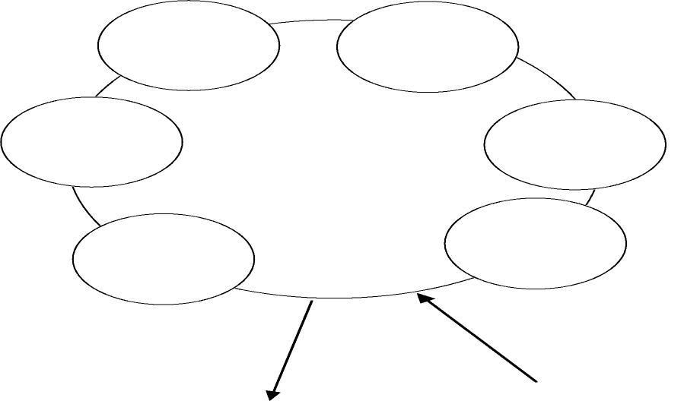
Reactions

Our experience is the product of our beliefs, identify the beliefs and check if they are truly real, at this point your experience has the opportunity to automatically change.
The Mechanisms of a Belief
- Attachment/Attention to a belief
- Belief creates a Filter to allow through only info that is consistent with itself
- Belief collects its own proof and evidence
- Belief creates its own Emotion, bodily reactions, feelings, expectations of reality etc
- Belief Manifests in Physical Reality
Exercise: Write down what your experience is regarding in sentences

Men Women Sex Life
Examples of Beliefs:
Life is Hard There is something wrong Men only want one thing
I’m unsupported by life Women betray you Love = Pain
I’m unworthy of Men/ Women can’t be trusted
I can’t

TRANSPARENT BELIEFS
‘A belief is transparent when you are operating through the belief without noticing it. Transparent beliefs are seldom helpful and, in fact, can be fatally debilitating. Most are self-sabotaging, adopted in a moment when you were something less than rational.
The first impression you have of a transparent belief is that it is unquestionably true. That's just the way life is. That's the way I am. Here's the proof! But then something funny happens: you discover that the proof for holding the belief is actually produced by the belief itself. A pattern begins to unfold.
Transparent beliefs are discovered by tricking yourself into expressing them and then stepping back and looking at what you said. Transparent beliefs are often hidden under the desire to be right, so finding transparent beliefs requires a degree of vulnerability.’ ~ Harry Palmer Living Deliberately
Belief Example

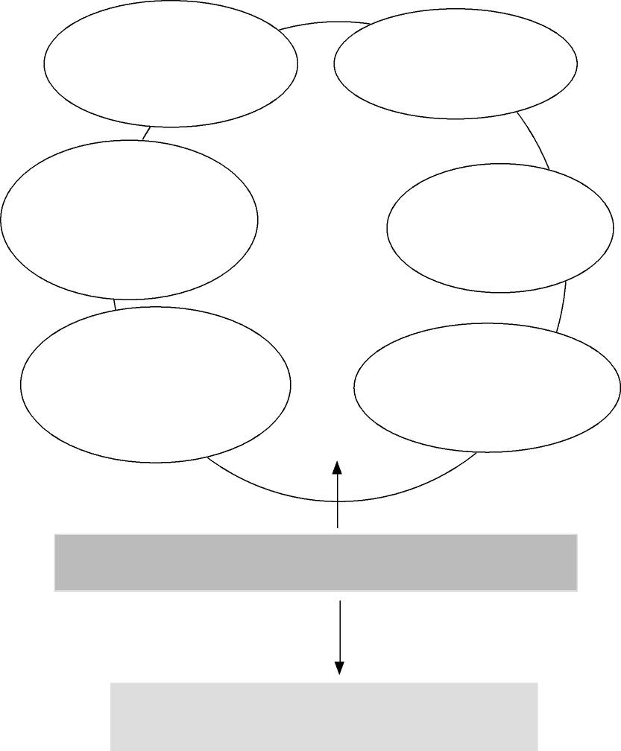
Evidence
Reactions
Nervousness Muscle tightness
Stressed Sleeplessness
Restless
Irritable
I have to prove I am good enough or
What’s the use?
Bodily Reactions
Well it happened before it will happen again
No one believes I am good enough
Thoughts
Expectations
good
enough
I’m not
Well my mother said I wasn’t
I can’t do what Sally did
Anxious Frightened
Self Conscious
Shy Overcompensating Defensive Easily hurt
Feelings
All experiences of life is filtered through this
belief in some degree or another
Reaction to life and output is filtered through a belief and
reacted to accordingly to secure the belief even further

UNDERLYING BELIEFS
- I need to know what to do  - I don’t know what to do  - I know what is best for others  - I know what is best for myself  - There is something to fear  - Something terrible is going to happen  - I need people to like me  - Its possible to make a mistake  - People should not lie  - People should respect me  - I need love approval and appreciation  - I can control how others feel about me  - I feel your energy  - I need to protect myself  - I can control how others feel about me  - I am not good enough  - I need to be different  - I need more money  - Life will be better in the future  - Life was better in the past  - Life should be fair. Life isn’t fair.  - I can make people happy  - I need agreement from others  - Parents should love their children  - I need to make a decision  - I should be further ahead in life  - Life is difficult  - I’m in the wrong place at the wrong time  - I would be happy if I had control  - It is possible to waste time  - Death is sad  - It is possible to miss out on something  - If I don’t suffer it means I don’t care  - There is something wrong with me  - I am stupid | - God will punish me if I am not good  - There is life after death  - There is something wrong with me  - I need to remember  - There is a right way to do things  - There is evil in the world  - I fear people’s opinion of me  - I can’t do anything right  - I can cause harm to others  - I can be manipulated  - I can disappoint people  - I need someone to care about me  - I don’t want to look foolish  - I don’t fit in here  - There’s too much to do  - There’s not enough time  - I have to get something done  - My life should have meaning  - My life has turned out wrong  - Other people should make me happy  - I am overworked and not appreciated  - I know what you need  - I need to control myself  - Men are bullies  - Women are vain  - I am worthless  - I need a man to make me happy  - I need a woman to make me happy  - I should be different  - I am a victim of circumstances  - Money provides security and happiness  - I missed my chance  - I need to be careful in life  - People should listen to me  - It is my fault they are the way they are

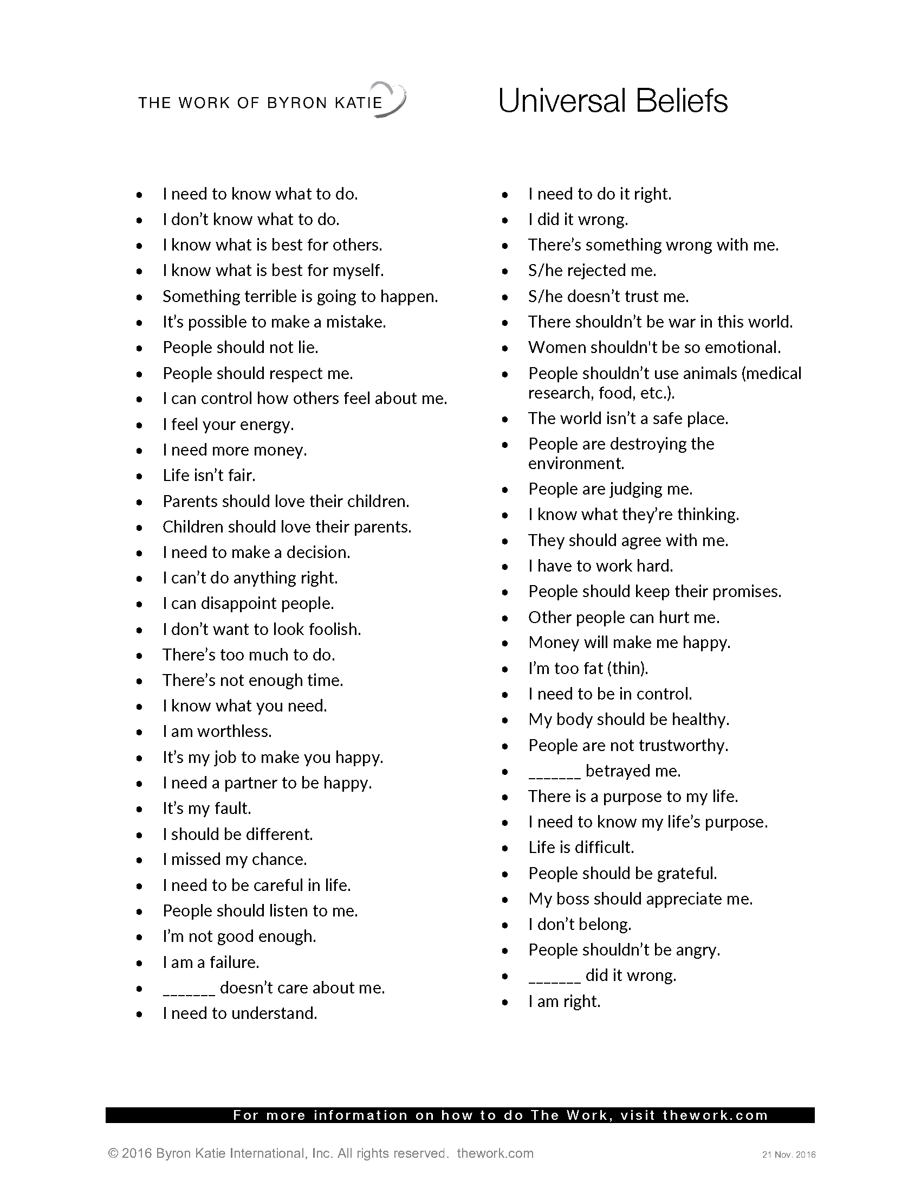

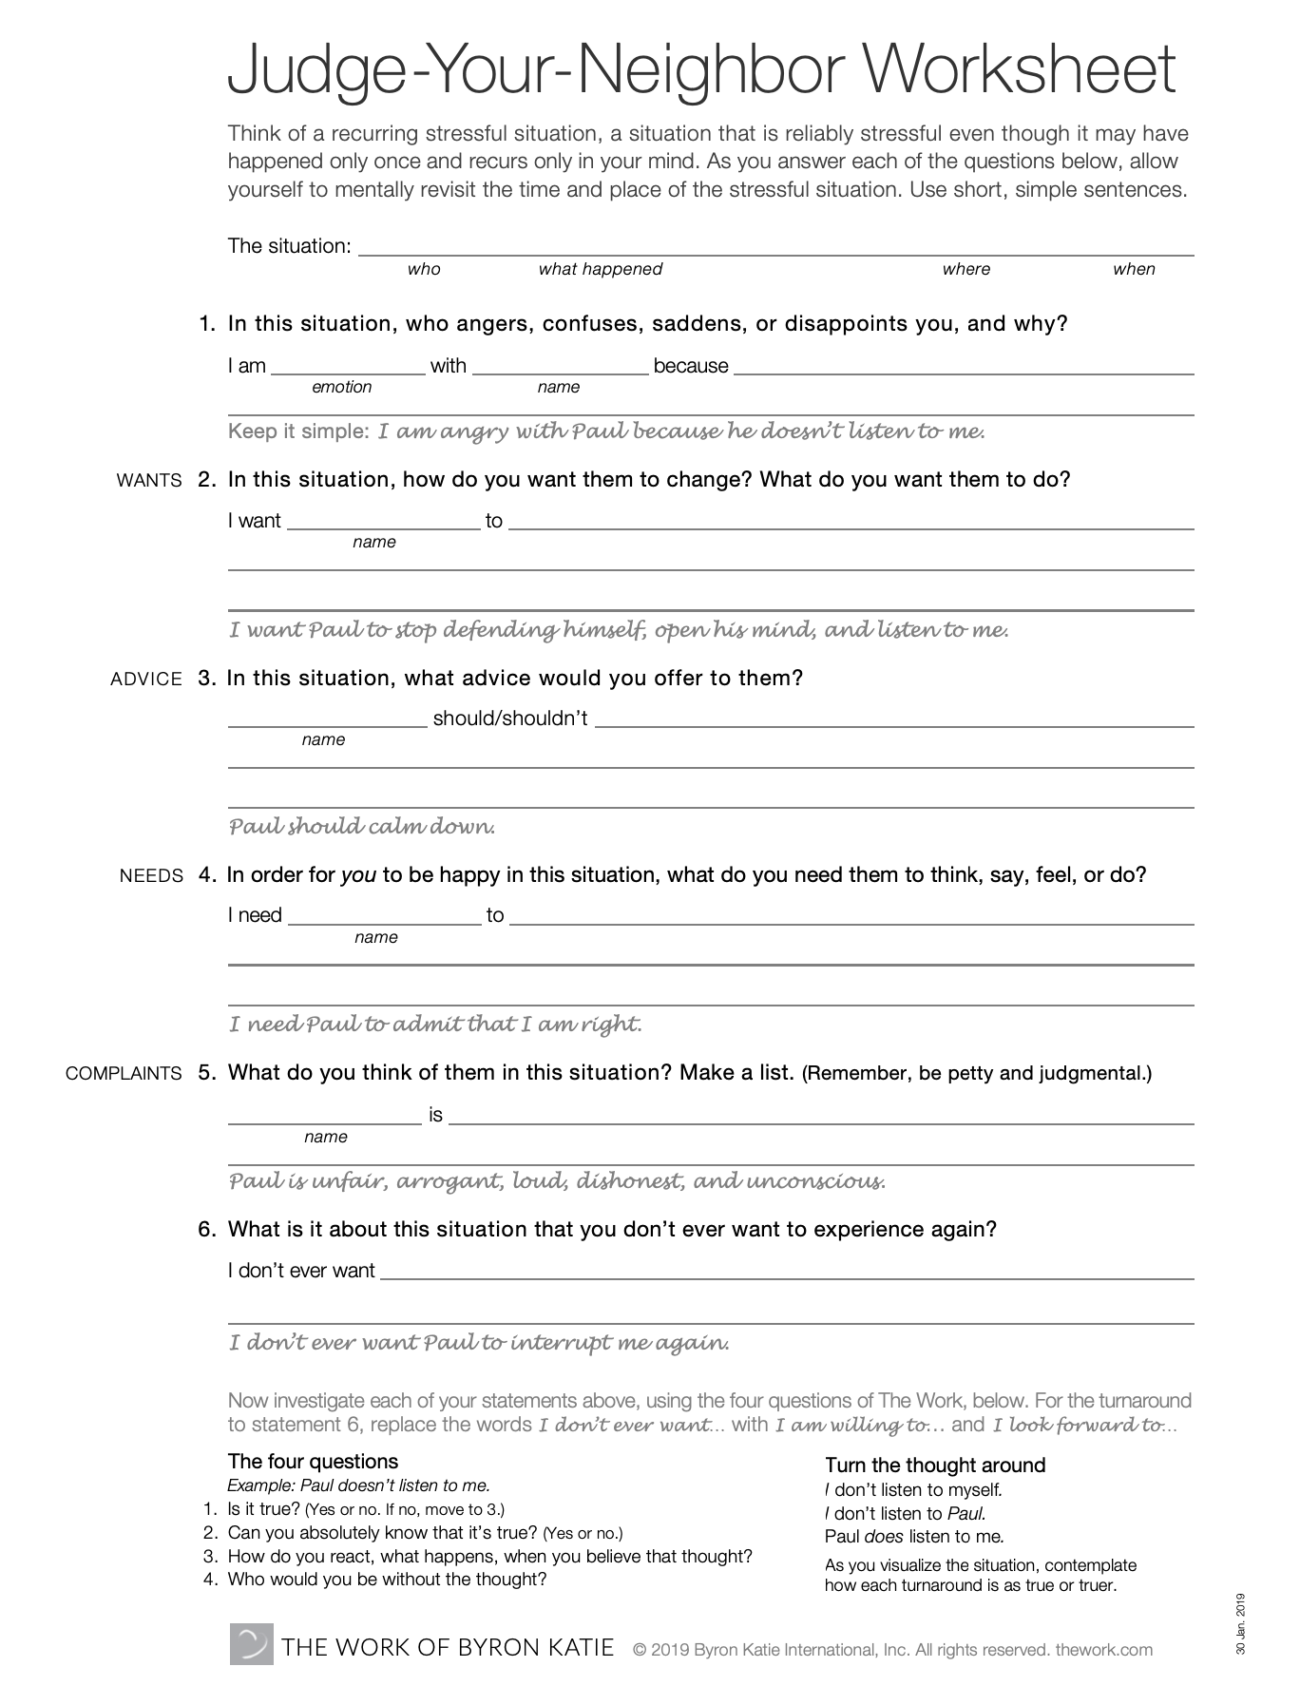

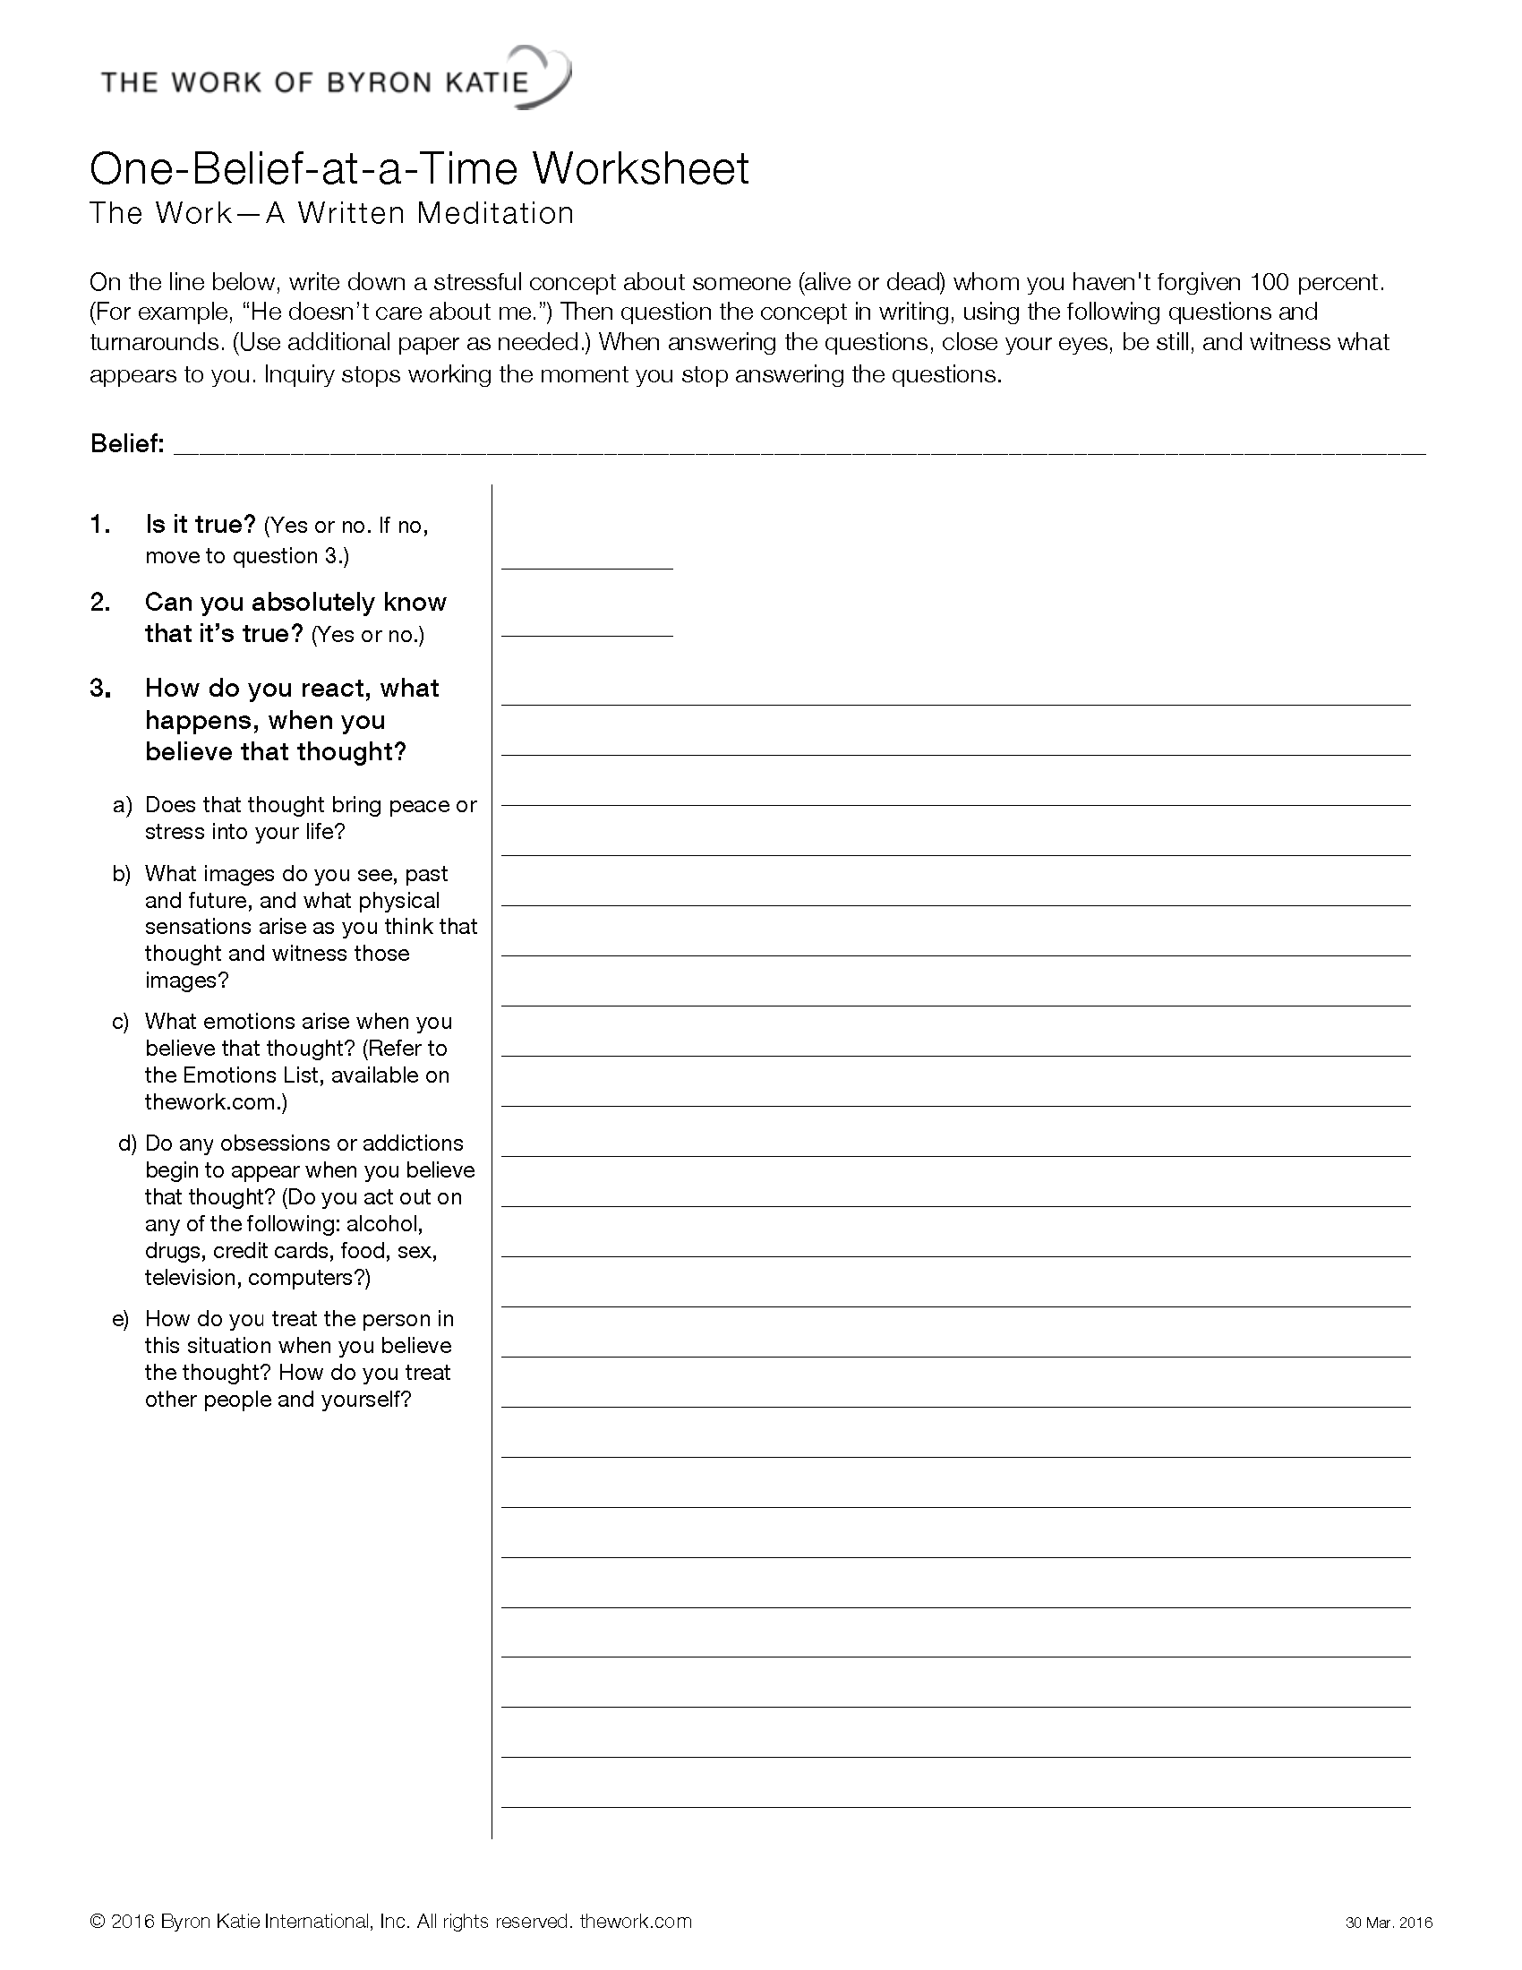

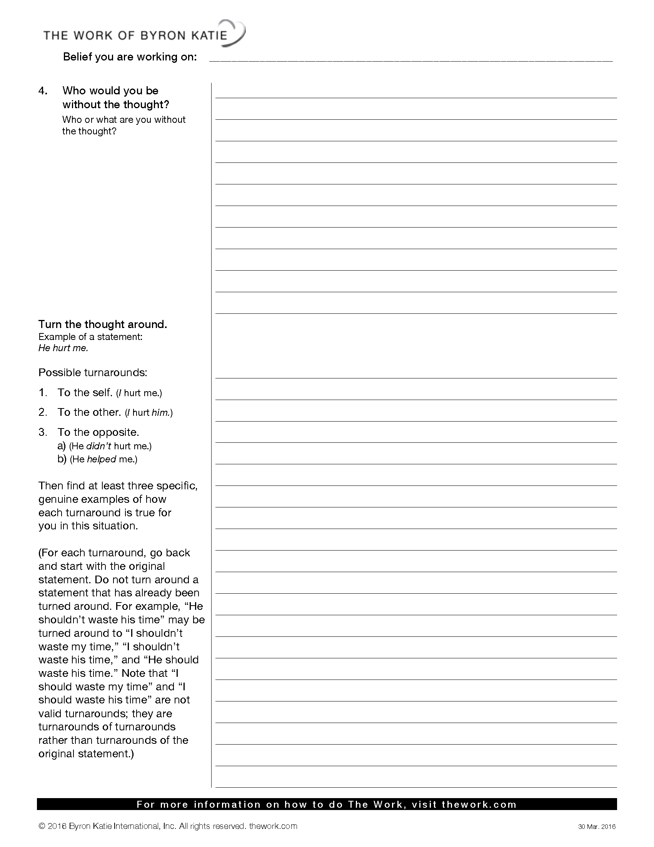
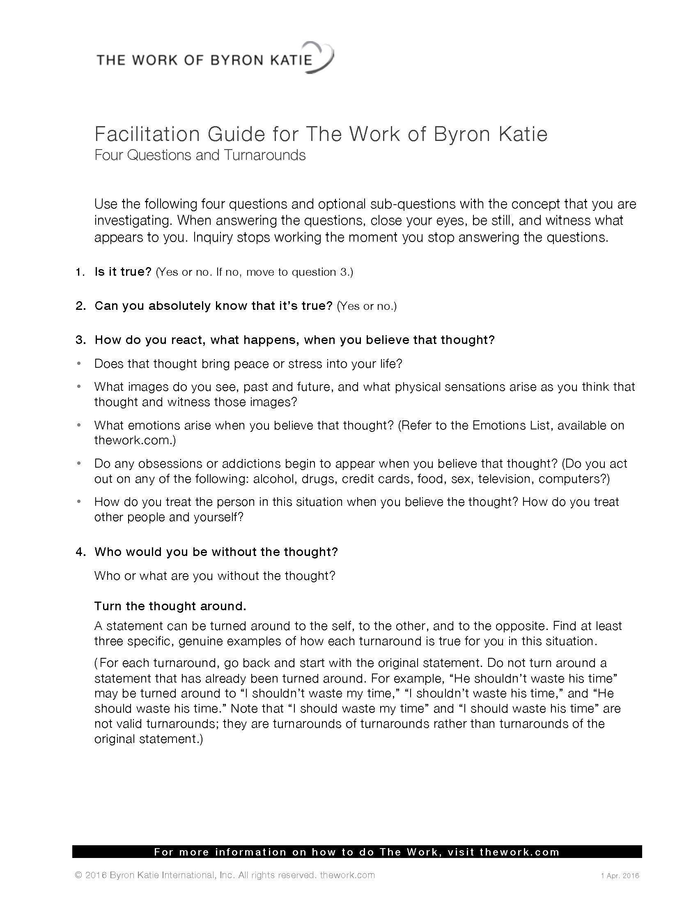

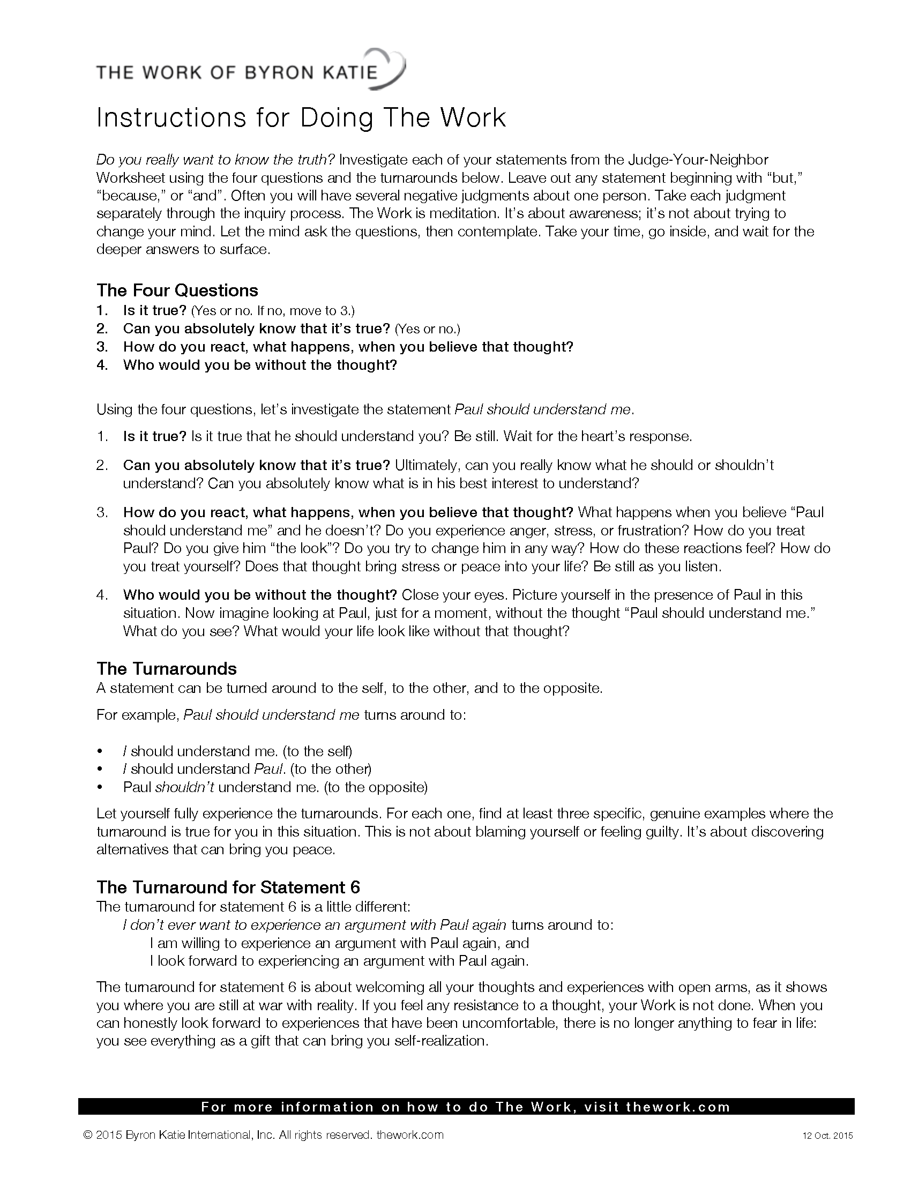
5. THE TURNAROUNDS
After you've investigated your statement with the four questions, you're ready to turn it around. Turnarounds are opportunities to experience the opposite of your original statement and see what you and the one you judge have in common.
Next turn your statement around. The turnarounds are an opportunity to consider the opposite of what you believe to be true. You may find several turnarounds.
For example: “Joe should understand me” turns around to:
- Joe does understand me” (Isn’t that reality sometimes) OPPOSITE TURNAROUND
- I should understand me (It’s my job, not his) ‘ME WITH ME’ TURNAROUND
- I should understand Joe (Can I understand that he doesn’t understand me?) ME WITH THE OTHER TURNAROUND
Let yourself fully experience the turnarounds. For each one ask yourself, “Is it true or truer?” This is not about blaming yourself or feeling guilty. It’s about discovering alternatives that can bring you peace.

STATEMENT #1 on Judge Your Neighbour worksheet
For example:
"I'm angry at Paul because he doesn't understand me"
For statement #1 only take the first part of the question out as we are not questioning in the feelings. Turn “Paul doesn’t understand me” around to:
"Paul does understand me." (Opposite turnaround)
Is that as true or truer? Could it be that I don't understand myself—perhaps the way I
repeatedly get so angry at Paul? If I don't understand myself, can I see how Paul wouldn't
either? Another turnaround could be
"I don't understand Paul" Can you find where that is true? (Me with Other turnaround)
“I don’t understand me” Can you find where that is true? (Me with Me turnaround)
Be creative with the turnarounds once you know the guidelines. They are revelations, showing you the unseen pieces of yourself reflected back through others. Go inside after each turnaround. Let yourself feel it. Ask yourself if any of your turned-around versions seem as true as or truer than your original thought, and if they do, find three genuine ways in which each of them is true.
As I began living the turnarounds, I noticed that I was everything I called you. You were merely my projection. Now, instead of trying to change the world around me (this didn't work, but only for 43 years), I can put the thoughts on paper, investigate them, turn them around, and find that I am the very thing I thought you were. In the moment I see you as selfish, I am selfish (deciding how you should be). In the moment I see you as unkind, I am unkind. If I believe you should stop waging war, am I waging war on you in my mind? If so, I am teaching war.
The turnarounds are your prescription for happiness. Live the medicine you have been prescribing for others. The world is waiting for just one person to live it. You are the one.
Statements can be turned around:
- To yourself (Me with Me) - You give what you want to yourself
- To the other (Me with the Other) - You give to the other what you want them to give to you
- To the opposite of the original statement (e.g.: turn it right – it’s what is, sometimes not use shouldn’t or I don’t want – but the actual opposite)
- To "my thinking," wherever it applies. (Where is the story happening really?). Don’t by pass me with other turnaround though
Try and find a minimum of three genuine examples in your life where each turnaround is as true as or truer than your original statement. The turnarounds are an opportunity to consider the opposite of what you believe to be true. You may find several turnarounds.

MORE EXAMPLES OF TURNAROUNDS:
"He should consider me" turns around to:
- He does consider me. (Isn’t this reality sometimes?)
- I should consider him. (Can I understand that he doesn’t understand me? And notice that sometimes I don’t consider him either)
- I should consider myself. (It’s my job not his and do I?)
"I need him to be kind to me." turns around to:
- He is kind to me. (At times?)
- I need me to be kind to him. (Can I live it?)
- I need me to be kind to myself.
"He is unloving to me." turns around to:
- He is loving to me. (To the best of his ability)
- I am unloving to him. (Can I find it?)
- I am unloving to me (When I don't inquire.)
"Paul shouldn't shout at me." turns around to:
- Paul should shout at me. (Obviously in reality, he does sometimes. Am I listening?)
- I shouldn't shout at Paul.
- I shouldn't shout at me. (In my head, am I playing over and over again Paul's shouting? Who’s more merciful, Paul who shouted once, or me who replayed it out a hundred times?)
EXAMPLES OF FURTHER TURNAROUNDS:
I am never good enough for my family.  I am always good enough for my family.  My family is never good enough for me.  My thinking about me is never good enough for me  I never have enough money.  I always have enough money.  It’s only in my thinking there is never enough money  I never have enough me.  I am not worthy.  I am worthy.  I am worthy of me.  It’s only my thinking that thinks that I unworthy | Sam does not support me when I need her to.  I do not support myself when I need me to.  I do not support Sam when she needs me to. Sam does support me when I need her to.  My daughter’s drug addiction is running my life.  My addiction to my thinking is running my life.  My addiction to my daughter is running her life.  My daughter’s addiction is not running my life.  My addiction to my daughter is running my life.  

excerpt from www.thework.com By Byron Katie
- ONLINE LIBRARY: Underlying Beliefs, Finding Underlying Beliefs, Emotions and reactions
- Deepening The Work article by Byron Katie
- Facilitation Guide http://www.thework.com/downloads/worksheets/instructions for thework.pdf
THE TURNAROUND FOR # 6 in JUDGE YOUR NEIGHBOUR WORKSHEET

“The Work is not about shame and blame. It’s not about proving that you are
the one in the wrong or they are the one in the right. The power
of the turnaround lies in the discovery that everything you think you see on the outside
is really a projection of your own mind. Everything is a mirror image of your own thinking. In discovering
the innocence of the person you judged, you eventually come to recognize your
own innocence.” (p.78 ‘Loving What is” By Byron Katie)
The turnaround for written statement #6, the last questions on the Judge Your Neighbor Worksheet, is a little different from the other turnarounds. When turning around the statements in #6, replace the words: “I don’t ever want to“ or “I refuse to ”
Turanrounds: “I am willing to………..” and then “I look forward to……..” ”
Example: “I don’t ever want to experience an argument with Paul again” turns around to:
- “I am willing to experience an argument with Paul again”
- “I look forward to experiencing an argument with Paul again.”
The turnaround for #6 is about welcoming all your thoughts and experiences with an open heart. If you feel any resistance to a thought, your Work is not done. When you can honestly look forward to experiences that have been uncomfortable, there is no longer anything to fear in life—you see everything as a gift that can bring you self-realization.
Each time you think that you are not willing to experience the anger, stress, or fear again, be willing to and look forward to it. It could happen again, even if only in your mind. This turnaround is about embracing all of life and it includes your thoughts, feelings, and experiences.
Saying “I am willing to...” creates openness, creativity, and flexibility. Any resistance that you may have is softened, allowing you to lighten up rather than hopelessly applying willpower or confrontation to eradicate the situation from your life. Saying “I look forward to...” actively opens you to life as it unfolds, even if it’s just in your mind. Inner freedom becomes an expression of love and ease in the world.
To be open to the possibility that the same situation might come up again allows you to relax. You don’t have to succeed in “fixing or letting go” of a certain thought. When you realize that suffering and discomfort are a call to investigate, you may actually begin to look forward to uncomfortable feelings. You may even experience them as friends coming to show you what you have not yet investigated thoroughly enough. It is no longer necessary to wait for people or situations to change for you to experience contentment and harmony. When it comes up you simply write it down, ask the four questions and turn it around. You allow yourself to give yourself a break.

LOVING WHAT IS: MEETING REALITY
THE TURNAROUND FOR Q # 5
There is another turnaround for question 5. That is when you look at all the questions above, from questions 1 to 4 on the Judge Your Neighbor worksheet and then look at question 5 we can clearly say:
“When I believe all the thoughts above then I become (what you have judge the other to be and listed in question 5)
Other turnarounds are:
Me with the Other (how I do what I judge the other for doing to them) Me with myself (how I do what I judge the other for doing to myself)
Opposite (This is often reality at times - the opposite ie They should do that – because this is what they are doing – it is reality)
QUESTION # 6 ON JUDGE YOUR NEIGHBOR WORKSHEET
After you have turned around the judgments in your answers to numbers 1 through 5 on the Worksheet (asking if they are as true or truer), turn number 6 around using "I am willing " and "I look forward to." For example, "I don't ever want to experience an argument with Paul" turns around to "I am willing to experience an argument with Paul" and "I look forward to experiencing an argument with Paul." Why would you look forward to it? Number 6 is about fully embracing all of mind and life without fear, and being open to reality. If you experience an argument with Paul again, good. If it hurts, you can put your thoughts on paper and investigate them. Uncomfortable feelings are merely the reminders that we've attached to something that may not be true for us. They let us know that it's time to do The Work.
Until you can see the enemy as a friend, your Work is not done. This doesn't mean you must invite him to dinner. Friendship is an internal experience. You may never see him again, you may even divorce him, but as you think about him are you feeling stress or peace?
In my experience, it takes only one person to have a successful relationship. I like to say I have the perfect marriage, and I can't really know what kind of marriage my husband has (though he tells me he's happy too).

See Articles The Work of Byron Katie: A New Psychotherapy by R Hidalgo Loving What Is Excerpt by Byron Katie

TURNAROUND EXERCISE
Turn the following thoughts around.
Tom does not respect me.
To myself: _______________________________________________________
To the other: _____________________________________________________
To the opposite: __________________________________________________
Martha lies to me.
To myself: _______________________________________________________
To the other: _____________________________________________________
To the opposite: __________________________________________________
I’m too fat.
To the opposite: __________________________________________________
To my thinking or my thoughts: _______________________________________
Pete should understand me.
To myself: _______________________________________________________
To the other: _____________________________________________________
To the opposite: __________________________________________________
Joan should be more considerate.
To myself: _______________________________________________________
To the other: _____________________________________________________
To the opposite: __________________________________________________
Louis smokes too much.
To myself: ______________________________________________________
To the opposite: _________________________________________________

Dan doesn’t appreciate my work.
To myself: _______________________________________________________
To the other: _____________________________________________________
To the opposite: __________________________________________________
I need Sally to be healthy.
To myself: _______________________________________________________
To my thinking: ___________________________________________________
To the opposite: __________________________________________________
I want my son to be happy
To myself: _______________________________________________________
To the other: _____________________________________________________
To the opposite: __________________________________________________
Greg is mean to me.
To myself: _______________________________________________________
To the other: _____________________________________________________
To the opposite: __________________________________________________
People shouldn’t abuse animals.
To myself: _______________________________________________________
To the other: _____________________________________________________
To the opposite: __________________________________________________
Your Belief:
To myself: _______________________________________________________
To the other: _____________________________________________________
To the opposite: __________________________________________________
Adapted from Copyright © 2017 Byron Katie Inc. www.thework.com

FURTHER TURNAROUND PRACTICE
(FROM A JUDGE YOUR NEIGHBOUR WORKSHEET)
Liz doesn’t care what I think
Opposite: (Reality): Liz does care about what I think
Me with Other (How I treat them): I don’t care what Liz thinks
Me with me (How I treat myself): I don’t care what I think
TRY THESE STATEMENTS AND TURN THEM AROUND FOR PRACTICE.
- I am angry at Matt because he is selfish and doesn’t consider others
Opposite: (Reality): ____________________________________________________________
Me with Other (How I treat them): __________________________________________________
______________________________________________________________________________
Me with me (How I treat myself): ____________________________________________________
______________________________________________________________________________
- I want Shelley to organize herself so others don’t get stressed
Opposite: (Reality): ____________________________________________________________
Me with Other (How I treat them): __________________________________________________
______________________________________________________________________________
Me with me (How I treat myself): ____________________________________________________
______________________________________________________________________________
- Sam should take responsibility for his actions and own what he did
Opposite: (Reality): ____________________________________________________________
Me with Other (How I treat them): __________________________________________________
______________________________________________________________________________
Me with me (How I treat myself): ____________________________________________________
______________________________________________________________________________

- I need Pam to communicate openly so there is no hidden agenda
Opposite: (Reality): ____________________________________________________________
Me with Other (How I treat them): __________________________________________________
______________________________________________________________________________
Me with me (How I treat myself): ____________________________________________________
______________________________________________________________________________
- Joe is selfish, inconsiderate, stubborn and never considers others
Opposite: (Reality): ____________________________________________________________
Me with Other (How I treat them): __________________________________________________
______________________________________________________________________________
Me with me (How I treat myself): ____________________________________________________
______________________________________________________________________________
Or When I think all the thoughts above (1 – 4) about __________ I become ___________________
______________________________________________________________________________

- I don’t ever want to feel excluded by my family again

I am willing to __________________________________________________________________
______________________________________________________________________________

I look forward to ________________________________________________________________
______________________________________________________________________________

6. ACCEPTING THE GIFT OF CRITICISM
When we understand precisely what criticism is really about, we find that criticism it is one of most powerful tools for self-realization and growth – if you really want to know the truth.
Here are some steps on how to use and understand criticism for your highest benefit.
When someone says you are “wrong, unkind, unclear, lazy” etc feel it. Settle into it before you strike out.
Ask yourself, “Is it true?”
“Could they be right?” Wait for the answer.
After the Criticism ask yourself:
“Was that stressful or painful?”
If the answer is yes, then this is a sign that you believe that the criticism is true, and that you haven’t dealt with it or gone deeply enough yet. If you want to end the war in your own life and mind, you may decide to gently go deeper as your inquire and discover the truth of the criticism within yourself. This is where all war ends.
No matter what anyone says to, or about, you if you experience stress, then you are the one who is suffering from your hidden secret – the secret you hide even from yourself in the moment – and the mind will do its job at this point which is to attack. Your own mind’s attack is the cause of stress. Stress is the signal that it is time to ask yourself, time to inquire, an opportunity for you to know the truth. Stress is always an opportunity to experience forgiveness with the people you judge and those who judge you, and to end the stress within you. Forgiveness cannot be found anywhere else. Forgiveness is when you realize that what you think happened didn’t.
Being honest with yourself and being vulnerable can be the end of the illusion of being manipulated in any way. When you are genuinely humble, there is no place for criticism to stick. This is where clarity takes on life as effective, kind action.
Inquiry is a direct internal path to freedom from the lie and from deep secrets, and therefore, freedom from the fear of your lies being discovered.

© 2017 Bryon Katie Inc. All rights reserved

7. PROOF OF TRUTH AND UNDERLYING BELIEFS

- What is the best advice you could give someone you live with or work with or is close to you in some way? Take time to consider and write.

Example -Michael should watch his diet.
______________________________________________________________________________
______________________________________________________________________________
______________________________________________________________________________
______________________________________________________________________________

- Write your proof of why each statement is valid advice
    - - Michael is gaining weight
    - - Too much weight is not good for his health
    - - He is sluggish and tired
    - ______________________________________________________________________________
______________________________________________________________________________
______________________________________________________________________________
______________________________________________________________________________
______________________________________________________________________________
______________________________________________________________________________
______________________________________________________________________________

- Find the underlying beliefs in the ‘proof’ statements
  - - People should not get fat, He should have energy
    - - People should live active fulfilling lives
    - - People should be healthy
______________________________________________________________________________
______________________________________________________________________________
______________________________________________________________________________
______________________________________________________________________________
______________________________________________________________________________
______________________________________________________________________________
______________________________________________________________________________
______________________________________________________________________________

- Break into pairs and investigate your list of underlying beliefs. If you are having difficulty naming underlying beliefs utilize your partner and explore possible beliefs held in your proofs. Make further notes of any underlying beliefs that may arise through inquiry.
30- 40 minutes each.

Adapted from ‘Loving What Is’ by Byron Katie ©2017 Byron Katie Inc., www.thework.com

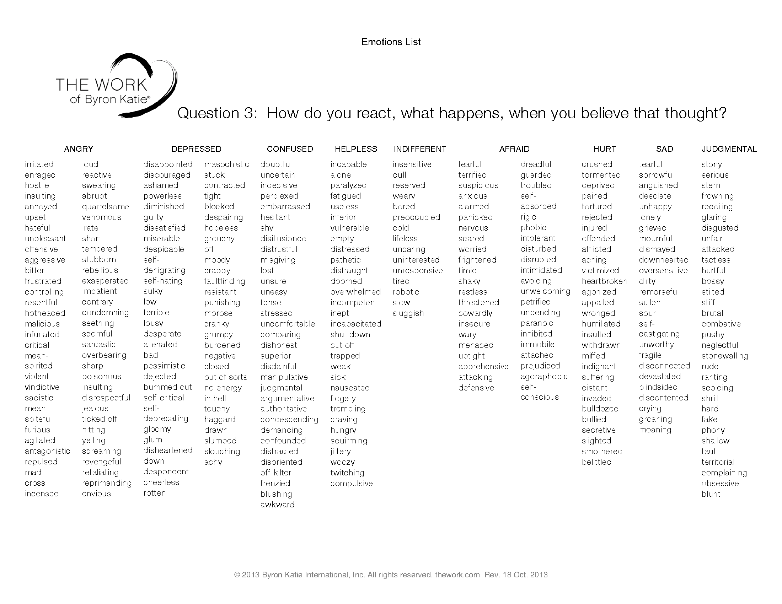

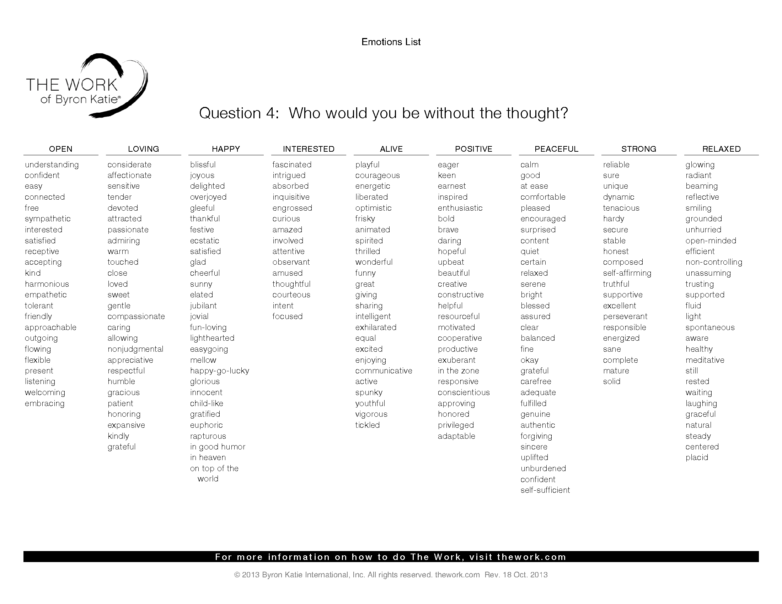

8. USING THE WORKSHEETS

When would you use the Judge Your Neighbour Worksheet? What presenting issues would prompt you to use the JYN worksheet?
______________________________________________________________________________
______________________________________________________________________________

Examples: ______________________________________________________________________________
______________________________________________________________________________

When would you use the One Belief at a Time Worksheet? What presenting issues would prompt you to use the OBT worksheet?
______________________________________________________________________________
______________________________________________________________________________

Examples:
______________________________________________________________________________
______________________________________________________________________________

When would you use The Work of Byron Katie?
______________________________________________________________________________
______________________________________________________________________________

What issues would you look to address using The Work of Byron Katie? Why?
______________________________________________________________________________
______________________________________________________________________________

RESOURCES

WEBSITES
Byron Katie’s website: http://www.thework.com
BK newsletters: http://www.thework.com/newsletter.php
BK Resources : http://www.thework.com/dothework.php
Rosie Stave’s website http://www.theworkwithrosie.com/
Wendy Davidson’s website: http://www.wde.com.au/index.html

HELPLINE
Experienced volunteers do The Work with you
http://www.instituteforthework.com/itw/content/helpline

9. MINI WORKSHEET

THE JUDGE-YOUR-NEIGHBOR MINI-WORKSHEET
Judge your neighbour • Write it down • Ask four questions • Turn it around
Fill in the blanks below on someone else, using short, simple sentences.
1. I'm angry, upset, saddened at _______________________ because _____________________
__________________________________________________________________________________.
2. I need ______________________ to _________________________________________________.
3. He or she should/shouldn't _______________________________________________________.
4. _______________________ is ______________________________________________________. (Describe them—don’t be kind. Be petty and judgmental.)
5. What two things do you most fear will happen in your life? (Not necessarily related to the above)

___________________________________________

THE JUDGE-YOUR-NEIGHBOR MINI-WORKSHEET
Judge your neighbour • Write it down • Ask four questions • Turn it around
Fill in the blanks below on someone else, using short, simple sentences.
1. I'm angry, upset, saddened at _______________________ because _____________________
__________________________________________________________________________________.
2. I need ______________________ to _________________________________________________.
3. He or she should/shouldn't ________________________________________________________.
4. _______________________ is _______________________________________________________. (Describe them—don’t be kind. Be petty and judgmental.)
5. What two things do you most fear will happen in your life? (Not necessarily related to the above)

SELF PACED LEARNING EXERCISES (OPTIONAL)
1. List the 3 types of business
- _______________________________________
- _______________________________________
- _______________________________________

2. What would be the result of putting your attention in each type of business
- _______________________________________
- _______________________________________
- _______________________________________
3. Outline the 3 turnarounds for a statement: Beth should be honest about what she does.
- _______________________________________
- _______________________________________
- _______________________________________

4. How do you turnaround Question 6? For this statement: I don’t ever want to feel anxious with him again
____________________________________________________________________________
____________________________________________________________________________

5. What is another way of turning Question 5 around in the worksheet other than me with me, me with the other and opposite?
____________________________________________________________________________
____________________________________________________________________________

6. What are the enquiry questions for Questions 1 -4? 1.
- _______________________________________
- _______________________________________
- _______________________________________

7. I want my mum to love me more. Turnaround it around.
To the opposite: __________________________________________________________________
To myself: _______________________________________________________________________
To the other: _____________________________________________________________________

8. Literal Listening involves what? What effect does it have on the listener?

____________________________________________________________________________
____________________________________________________________________________
____________________________________________________________________________
____________________________________________________________________________

- When would you use the One Belief at a Time Worksheet?
____________________________________________________________________________
____________________________________________________________________________
____________________________________________________________________________
____________________________________________________________________________

- Using the Facilitation Guide. What other questions would you ask after you have asked: Can you absolutely know that it’s true?
____________________________________________________________________________
____________________________________________________________________________
____________________________________________________________________________
____________________________________________________________________________
____________________________________________________________________________
____________________________________________________________________________
____________________________________________________________________________
____________________________________________________________________________
____________________________________________________________________________

“An unquestioned mind is a world of suffering”
Byron Katie

Interested in more of The Work of Byron Katie?
Join us for Part II & III https://awakening.com.au/course/the-work-of-byron-katie/

JOIN US
www.awakening.com.au

